

Tranquil Woods Go / No Go Decision
Contents
Woodland Go / No Go Decision 1
Introduction 2
Background 2
Due diligence findings 4
COTS Report 4
Tree Survey 5
Insurance 5
Grants 5
Covenants 6
Stakeholders 7
Using CIL funds to purchase Tranquil Woods 7
Access and parking 8
Ongoing Management 8
Costs 8
Spend to Date on the Woodland 8
Forecast spend to purchase 9
Forecast spend to complete initial setup 9
Forecast Annual Cost 9
Forecast Year 1-2 Costs 10
Notes 10
Risks & Issues 10
Decision Pros and Cons 13
Next steps if GO 13

Items to Note
- New covenants have not yet been confirmed
- Price cap of fees has not yet been agreed with seller
- Doners have not been approached.
- A small group of 20 volunteers have been formed in the Friends of Tranquil Wood under reBetchworth.

Introduction
Betchworth Parish Council is required to make a decision on whether to recommend proceeding with the purchase of Tranquil Woods. Due diligence has been completed and forecast costs have been laid out in this document. Parishioners to be consulted if a GO decision is recommended and Council will proceed to purchase the wood if positive feedback is received from the consultation.

Background
Betchworth Parish Council has the opportunity to acquire a significant part of Tranquil Wood (Figure 1) as a permanent nature-based community asset, to benefit the residents of Betchworth and Buckland for generations to come.
The owner of the woodland is persuaded by our vision of a nature asset for the community and has chosen to make it available to the community at a fraction of its commercial value. This kind of opportunity is extremely rare. In taking the opportunity to acquire the land, the Parish Council will itself be creating a legacy for the benefit of residents of Betchworth & Buckland.

Figure 1: Tranquil Woods boundary as confirmed with the current owner
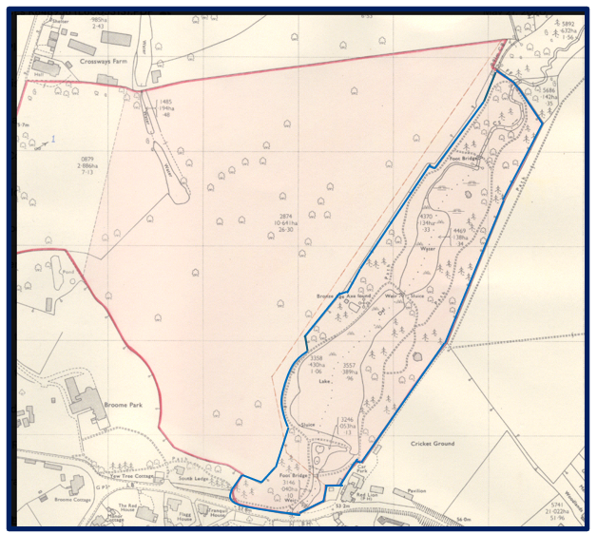
Tranquil Wood is a twelve-acre fragment of ancient woodland along the shallow valley of Slough Brook, on the boundary of Betchworth and Buckland parishes, immediately south of the A25. It is one of those places that repays quiet attention: snowdrops, wild garlic and bluebells in spring; badgers, deer and foxes; reed beds, a pond that grow in the winter and transient wetland nurtured by the brook; a canopy shaped by centuries of natural process and human stewardship.
Inside Tranquil Wood lies an ancient woodland (i.e. it’s been here since at least 1600AD) and a grade 2 listed Folly. The woodland soils, seed banks, fungal networks and hydrology carry ecological histories that modern planting cannot replicate making it an important biodiversity habitat. The woodland is a key mitigation asset for extreme climate events due to its large number of deciduous trees providing shelter to wildlife and keeping the soil cool from the sun.
Ownership by Betchworth Parish Council would transform the woodland into a shared civic asset — protected in perpetuity, managed transparently, and available to the whole community. In practical terms, it would mean:
- With careful management, it will be a refuge for rare wildlife species along the Slough Brook corridor, covering two significant habitats: ancient broadleaf woodland and riparian wetland.
- A living classroom for local schools, families and nature groups.
- An important habitat in the centre of the village which is on the Betchworth and Buckland Nature Trail.
- A place of quiet and restoration for residents — the kind of accessible natural space that evidence consistently links to physical and mental wellbeing.
- With careful management, it will continue to be a keystone habitat within Surrey's emerging Local Nature Recovery Strategy, demonstrating that communities can and do play an active role in nature recovery.
- A opportunity for large volume flood attenuation through management of the Tranquil Woods ponds.
- An opportunity to restore the grade 2 listed folly / temple once used as an icehouse.
There has been no management of the woodland for over 60 years and therefore we will need to do some initial works to fix the fence (using volunteers creating a dry-hedge) and de-risk the trees along the public footpath / road bordering Tranquil Woods.
Following the initial works, we will work in accordance with our strategy (Tranquil Woods – Betchworth Parish Council), and where funds allow, to remove invasive non-native plants, create a footpath through the woods, capture nature studies, setup a forest school area and form a plan for the pond management.

Due diligence findings

COTS Report
Tranquil Wood is a 4.95-hectare, partly designated Ancient Semi-Natural Woodland with significant ecological, cultural and recreational potential. Its principal constraints are hazardous and deteriorating infrastructure, unsafe trees, invasive plants, limited access, damaged boundaries and uncertain seasonal drainage. The recommended priorities are to reduce immediate hazards, complete the required ecological and tree surveys, establish controlled public access, restore woodland structure and biodiversity, and adopt a phased management programme supported by community engagement. Please refer to COTS report for further information.
Constraints noted:
- Ash Dieback, Badgers, Bracken, Bramble, Deer, Rabbit, Roadside, Rubbish & Detritus, Squirrel, Topography, Water Features
- Bamboo, Bindweed, Laurel, Rhododendron
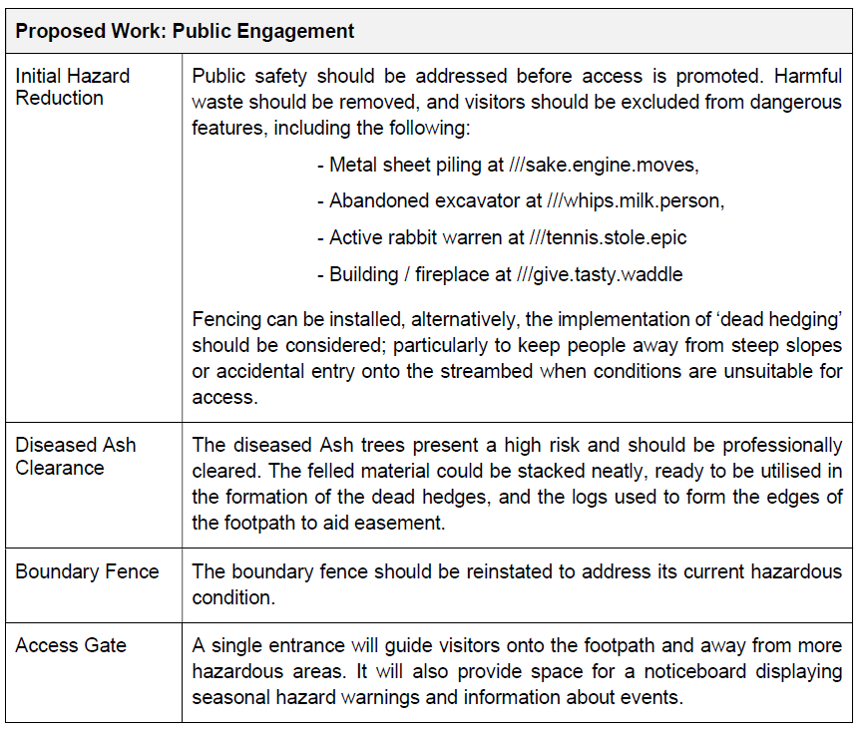

Tree Survey
A tree survey has been completed by a qualified surveyor of the boundary of Tranquil Woods adjacent to the public road and footpath. 4 tree surgeon’s have been asked to quote for performing the tree works as listed in the costs section.

Insurance
The Council insurers have confirmed that the woodland can be incorporated into our cover at no additional cost (we have a policy which covers all Council owned land and specific itemised assets). The trees and assets on the land would not be covered unless explicitly itemised in the policy.

Grants
The following grants are available to apply for:
Description | Value | Link
The National Lottery Heritage Fund - conserve and enhance habitats and protect and preserve species  improve threatened or fragmented habitats  slow river flow and improve water quality  use nature and being outside to improve people’s lives, health and wellbeing | £10m | Habitats and species | The National Lottery Heritage Fund
Green Community Grants Programme | The Wildlife Trusts (Apply 30 Sept-21 Oct 26) | £25k | Green Community Grants Programme | The Wildlife Trusts
Veolia Environmental trust | £75k+ | Eligibility checker - Veolia Environmental trust  (Note 10% CTP payment)
Surrey Council Climate Resilience grant | £15k | Included Tranquil Woods in grant application alongside other measures
Natural England |  | https://www.gov.uk/government/publications/countryside-stewardship-higher-tier-csht/csht-applicants-guide

Covenants
There are the following existing covenants on the land:
- Electric sub station: Lease dated 22 February 1965 of an electricity sub station site hatched blue on the filed plan to The South Eastern Electricity Board for 42 years from 25 December 1964.
- Sewer pipe: FULL right and liberty to lay and maintain under the Vendors land in the position indicated by a red line on the plan attached hereto a sewer for the purpose of conveying sewerage to the sewerage plant of the grantee and to instal any manhole covers as may be necessary for such purposes.
- Sewer pipe: FULL right and liberty to enter on so much of the Vendors adjoining land as may be necessary for such purposes and for the purpose of inspecting maintaining and renewing such sewer from time to time with all necessary apparatus and machinery subject to doing as little damage as possible to the Vendors land and making good all damage occasioned thereby including properly levelling the land disturbed.
- Boreholes: Property Description: Site for observation boreholes Date of Lease: 24.11.2005 Term: 25 years from 21.3.2005 Lease ID: SY744743
The owner has confirmed that new covenants will be added as part of the sale. These have been requested for Council to review.
There are the following existing groups who have agreement with the current owner to use the woodland:
- the cricket club to collect their cricket balls
- the sewer company to service their pipe (existing covenant)
- the electricity company to service their sub station site (existing covenant)
- the tent owner has no permission and it is disused/abandoned
There are the following utility pipes through the woodland:
- No power lines
- No gas pipes – these run under Old Road
- Sewer pipe

Stakeholders
The following local groups have been informed of the Council’s intention to purchase Tranquil Woods:
- Pilgrim cricket club
- Red Lion pub
- Buckland estate
- Buckland parish council
Public consultation was held on 18th May 2026. If Council decision is a GO, then follow on public consultation is planned for September 2026.

Using CIL funds to purchase Tranquil Woods
"The neighbourhood portion of CIL can be used to support the development of the area, or any part of that area, by funding the provision, improvement, replacement, operation or maintenance of infrastructure; or anything else that is concerned with addressing the demands that development places on an area."
Tranquil Woods village nature reserve would meet this requirement and therefore CIL funds can be used to purchase the woodland.
Public access will be provided as soon as funds allow internal tree works and an accessible path to be created in accordance with the Tranquil Woods strategy. Visitors would be able to use the footpath to enjoy the woodland and local groups to enjoy the forest school area.
New residents place strain on existing village amenities and parks. Managed ancient woods provide peaceful, tranquil spaces that allow communities to de-stress and reconnect with nature. Offering designated walking trails and wildlife corridors alleviates the recreational load on smaller village greens while promoting physical health and reducing the burden on local healthcare services.
Increased traffic and construction generate significant airborne pollution, constant noise, and artificial light, which degrade the tranquil character of rural villages. Mature, dense tree canopies and complex understories serve as physical "green buffers". They trap harmful particulate matter (PM2.5 and PM₁₀) from vehicle exhausts and absorb sound waves to significantly reduce traffic noise.

Access and parking
Possibility of a pedestrian public access gate on the Buckland Estate field corner.
Red Lion landlord has agreed to a pedestrian gate and a maintenance gate to access the woodland from his car park. Must give notice of maintenance to ensure cars aren’t parked in-front of the gate when in use.
Red Lion landlord is raising the access with his freehold owner (Heineken) and will put our Solicitor in touch with them. He wants parking spaces for customer use only. Visitors would park in the nature trail car park at the Church.

Ongoing Management
- A management team and terms of reference have been agreed by Council available on the website: Tranquil Woods – Betchworth Parish Council.
- The woodland would be maintained in accordance with the Tranquil Woods strategy Tranquil Woods – Betchworth Parish Council, plus the addition of bamboo maintenance.
- Ongoing tasks would involve
  - annual tree survey and completion of recommended tree works
  - maintenance of the path to keep it clear and accessible
  - maintenance of boundary hedge / fence
  - maintenance of forest school area
  - treatment of bamboo

Costs
Spend to Date on the Woodland
£ 100 | COTS Report and tree Survey travel expenses ex vat
£ 1,355 | COTS Report and tree Survey (boundary line) ex vat
£1,455 | TOTAL

Forecast spend to purchase
Phase | Item | Total exVAT £ | Status
Purchase | Purchase land | 10,000 | Price agreed with seller
Purchase | Seller fees | 10,000 | Fee estimates
Purchase | Council solicitor fees | 5,500 | Estimate provided by approved solicitor
Purchase | Contingency on solicitor fees | 1,100
Purchase | Valuation | 1,500 | Quote approved by Council
 | TOTAL | 28,100

Forecast spend to complete initial setup
A reBetchworth volunteer group has been setup to help manage the woods and they have received a grant from Surrey Council to buy tools and receive training.
The initial costs are expected to be as follows:
Phase | Item | Total exVAT £ | Status
Initial setup | Initial tree works to de-risk trees along road and public footpath | 10,000 | Quotes being received
Initial setup | Felling licence | 0 | No charge
Initial setup | Fencing – wire mesh to supplement repair of existing fence along with installation of dry hedging by volunteers & gate | 300 | Estimate
Initial setup | Signs | 300 | Estimate
Initial setup | Fence off broken railings where stream meets Old Road | 100 | Estimate
Initial setup | TOTAL | 10,700

Forecast Annual Cost
Project activities listed in the Strategy would proceed once in receipt of grants. Annual required maintenance would be as follows:
Phase | Item | Total exVAT £ | Status
Annual | Tree works | 2,000 | Estimate, maybe volunteer task
Annual | Tree Survey | 1,500 | Estimate
Annual | Fencing repair – dry hedging | 0 | Volunteer task
Annual | Maintenance - signs | 500 | Volunteer task
Annual | Bamboo treatment | grant | Estimate
Annual | Monitoring device | 1,500 | Quote
 | TOTAL | 4,000

Forecast Year 1-2 Costs
A grant will be applied for immediately after purchase to fund further works in Tranquil Woods in accordance with the Tranquil Woods Strategy.
Phase year 1 | Item | Total exVAT £ | Status
year 1 | Tree survey of internal path & forest school | 500 | Estimate
year 1 | Tree works to de-risk trees along internal path / forest school | 10,000 | Estimate
year 1 | Make internal path / forest school area | 0 | Volunteer activity
year 1 | Bamboo removal including digger hire and chemical spray | 2,000 | Volunteer + estimate
year 1 | Signs | 300 | Estimate
year 1 | Ecology Survey | 3,000 | Quote approved by Council
year 1 | Digital Mapping and Path Mapping (Map the property’s boundaries, access points, hazards, features, sensitivities and notable trees to support well-reasoned management decisions.) | 50 | Volunteer activity
year 1 | Fence off metal sheet piling and remove broken excavator | 1,000 | Estimate
year 1 | mend broken railings where stream meets Old Road | 1,000 | Estimate
year 1 | metal gate entrance by car park | 2,000 | Estimate
year 1 | install water monitoring device | 4,805 | Quote
 | TOTAL | 24,655

Notes
- Although 4 tree surgeon’s were asked, none were prepared to quote for the bamboo works. An assumption has been made.

Risks & Issues
Description | Impact | Probability | RAG | ACTION | Health and Safety Risk
IF the maintenance costs are higher than can be sourced via grant THEN income source needed to maintain the woodland | Med | Med |  | Budget to use Burial Ground income to maintain the woodland or raise precept. | no
IF visitors wander off the path THEN visitors could trip / injury whilst on the woodland | Med | Low |  | Public liability insurance  safety risk assessment  Preventative measures such as tree and path maintenance | yes
IF visitors/pets disturb wildlife/ rare flowers/trees THEN ecology changed | Med | Low |  | Put up signs,  Consider boardwalk style visitor footpath | no
IF lots of visitors visit with their cars THEN the road could get blocked and neighbour considerations | Med | Low |  | Signs to park considerately at the Churchyard  Accept risk. | yes
IF ecology survey records a protected species on the planned path / forest school area THEN the woodland strategy changes | High | Low |  | Budget for an ecology report and a map to be created of the protected species in the woods, with a plan for where the path and forest school area will go. Consider a boardwalk to avoid human / pet contact with the protected species | no
Given THAT there are ancient & veteran Trees and a historic lack of management in the woods THEN risk IF deadwood / canopy collapses / Trunk splitting / root failure THEN Crush or strike injuries | High | Low |  | Procure a Professional Tree Safety Survey annually within 20m of spaces adjacent to public use  Enforce a 15-meter Root Protection Area (RPA) buffer.  Cordon off areas during high winds (>40 mph).  Log all completed inspections and remedial works using a standard template to maintain an official safety audit trail. | yes
Given there is a marsh & seasonal open water ponds risk IF visitors slips, trips, drowning, Deep mud entrapment, Biological hazards (Weil’s disease) THEN visitors injured | High | Low |  | Install visible deep-water warning signage.  Consider building raised boardwalks with non-slip mesh.  Provide lifebuoys if deep open water pools exist.  Use signs to keep visitors on the path if not a boardwalk.  Use natural deadwood barriers to block marsh entry. | yes
Given the Folly is grade 2 listed Stone Structure IF Falling masonry / structural collapse from Confined space hazards THEN Minor falls from climbing | High | Low |  | Restrict structural access using perimeter fencing.  Erect clear "Danger: Unstable Structure" signs.  Schedule a structural integrity check by a surveyor. | yes
Given the site is a wild 10-Acres with Remote worker or visitor isolation IF Slips on uneven terrain/exposed roots / lyme disease from tick bites THEN visitor injury | Med | Med |  | Advise sturdy, ankle-supporting footwear in welcome sign  Post tick awareness signs advising long trousers.  Establish a strict lone-worker check-in procedure for maintenance workers  Clearance of low-hanging branches and fallen logs.  Routine strimming of brambles/nettles.  Level highly uneven areas in the path  Install "Uneven Ground" signage | yes
IF path becomes legally a permanent Public Right of Way through 20 years of continuous use under the Highways Act 1980 THEN path route can not be easily amended if woodland strategy changes | Low | Low |  | Install signs explicitly stating "Permissive Footpath: Permission to use may be withdrawn at any time."  Formally close the footpath for one full day each year and document it to legally break continuity of public use.  Conduct monthly walked inspections of the path, logging all findings and clearance actions in a dedicated safety diary. | no
IF public consultation comes back negative or  IF the purchase process uncovers a large risk  IF an agreement with the Red Lion can not be reached regarding an access point into the woods for visitors and maintenance  after Council have made their decision THEN Council may wish to review their decision and may then have purchase and setup costs which can’t be claimed under CIL funding. | Med | Med |  | Make an agreement that Council can review their decision after public consultation  Use reserve funds if required | no
IF the Owner pulls out of the sale after Council have spent money on the purchase THEN setup costs which can’t be claimed under CIL funding. | Med | Med |  | Regular communication  Quick sale | No
Given THAT Solicitor fees are an estimate IF solicitor fees go over budget THEN more funds required to purchase Tranquil Woods | Med | Med |  | Regular updates from Solicitor  Use reserve funds if required | no
Given THAT the Climate is changing and extreme events are more regular IF flood/fire THEN visitor safety and biodiversity damage | Low | Low |  | Maintenance of woodland edges  Warning signs for visitors and a emergency exit plan on the welcome sign | yes
Given THAT there is a lot of Invasive species in the woods IF species can’t be removed THEN annual maintenance cost increases | Low | Low |  | Annual review of status by woodland management team | no
Given THAT the FoTW team size is currently being formed, IF able bodied volunteers are not available to complete tasks THEN additional cost to source a supplier for these tasks | Med | Med |  | Comms with community  Regular volunteer slot e.g. Mon mornings | no

Decision Pros and Cons
Council needs to decide - is this a good value investment for the Council?
Benefits
- nature preservation opportunities,
- water attenuation opportunities,
- home for the forest school
- visitor facility,
Cons
- annual maintenance,
- visitor use is not possible until more funding is supplied for initial setup and then to put in a fully accessible path
- requires sponsorship investment if grants not successful
- access not yet confirmed

Next steps if GO recommended
- Community consultation
  - A vote / poll for Betchworth parishioners only
  - Paper copies of vote available in Post Office
  - Parish Magazine article
  - Consultation ends 7th October
  - Parish Council to then decide Go/No Go Decision.
- Engage solicitor
- Engage valuation

Footnote: Article from Surrey Hills Society – Volunteer Rangers
Successive Governments have committed the UK to the global ‘30 by 30’ target (The 30 by 30 Goal | 30x30 UK): ensuring 30 percent of land and sea are effectively managed and protected for nature by 2030. In practical terms, this means moving from assuming designated nature sites are in good condition ‘on paper’ to actively restoring habitats, improving protected sites and connecting green spaces.
In the Surrey Hills, we have the highest woodland coverage of any protected landscape in England, much of it ‘on paper’ within protected sites. Yet much of our woodland isn’t effectively managed and is in declining condition, with wildlife numbers and rare habitats such as our chalk downland suffering as a result.

