

Skooter Park
Contents

Skooter Park 1
Introduction 1
The Park 2
Location 3
Survey results 4
Permissions 4
Eco/drainage considerations 5
Risks 5
Costs 5
Next Steps 6
Appendix A: Survey Responses 7

Introduction
A working group of local parishioners would like to install a Skooter Park at the corner of Wellhouse Lane.
The working group visited Betchworth Parish Council last year and since have recently completed a survey of Brockham and Betchworth parishioners.
The working group have spoken to County Councillor Helyn Clack and 2 suppliers: Fearless Ramps and Skaterham.
Council are requested to consider if they support the initiative and if they would take on ownership / insurance / maintenance of the equipment once it has been installed.

The Park
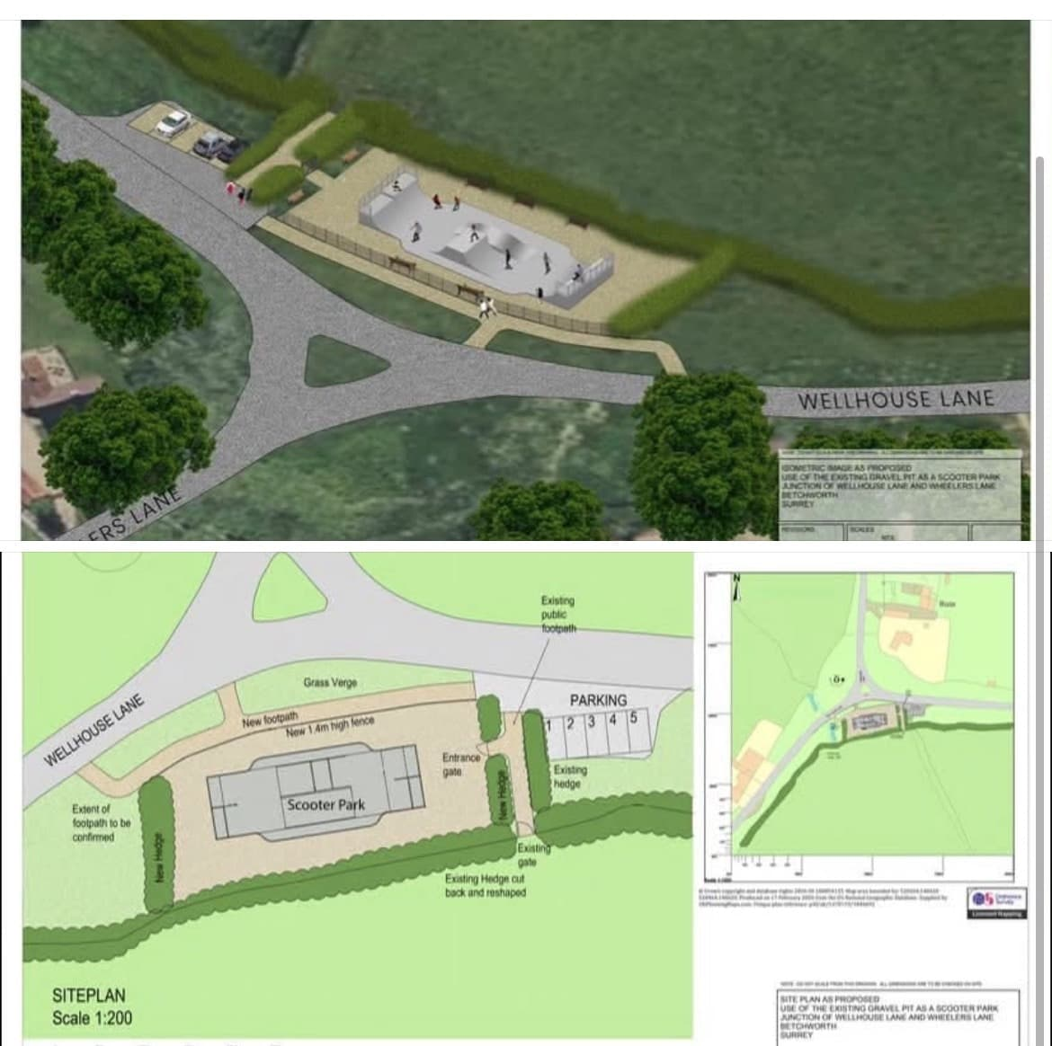

The Park would consist of a set of low steel frame with Skatelite composite decking. The benefit of the site is it already has a concrete floor so the base is already there. The new ramp can use the existing concrete as a base. The ramps can be used by scooter users, roller blade users, skate boards and small bikes. The ramps are not proposed to be tall and designed for use up to age 10.
From a health and safety perspective, the ramp itself must be fully enclosed so that access to the framework is denied, and the landings need to be boarded completely.
The trees and hedges around the park would require some attention to facilitate a better view of the bend and the junction as vehicles pass the park.
A chicane type fence could be installed at the entrance to the park, which would help to prevent children and adults from going out onto the road without due care and attention.
A bin and some seating for parents would also be welcome.
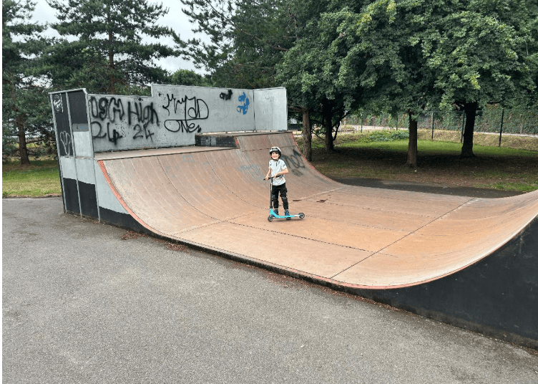

Location
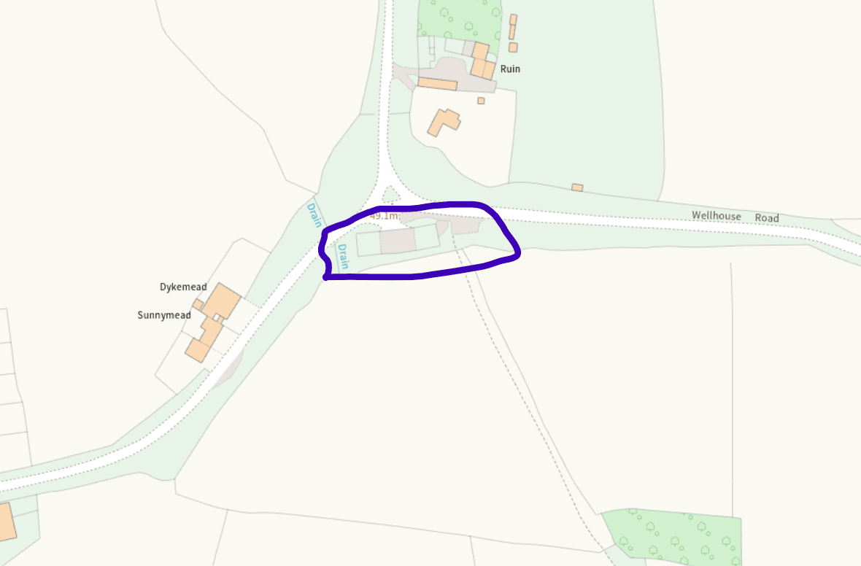
The area of the gravel pit is roughly 14m x 40m

Survey results
150 replies, 85% positive
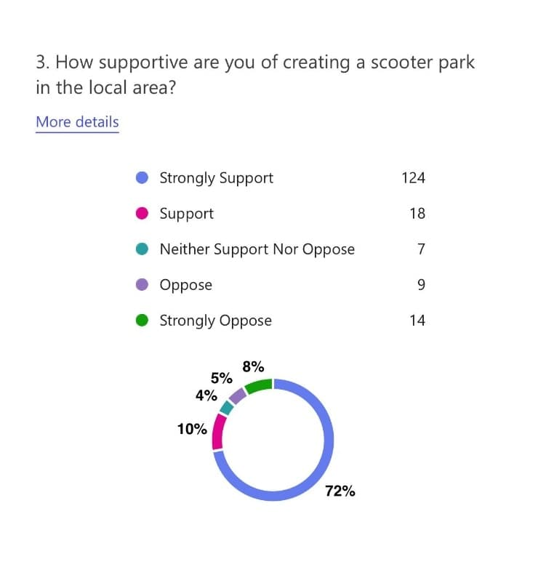

Permissions
Originally this land belongs to the Betchworth Estate. There was a long term lease on the land to County Highways. The team have verbal agreement from Joosje Hamilton for the project.
Planning permission would be required for the project except if the Highways lease is still valid.
The land itself when looked at on land Registry forms part of the parcel that includes the road itself, so you would assume either owned or adopted by SCC Highways. However, Helyn Clack has emailed
“that the Betchworth Estate owned the land, but that Surrey County Council had highways designation rights over it.
This would be an archaic arrangement under 'manorial rights and waste' - I arranged for a letter of comfort from the county council which was sent to the two parish councils from Surrey Highways confirming that they no long required these highway rights. This will be recorded in the parish minutes.
It would, therefore revert to Betchworth Estate who at the time were willing to lend it to the skateboard park project.”
However checking the historic Council minutes doesn’t confirm this.
- August 2014 - Skatepark To confirm that no planning permission will be sought public meeting – independent Chair
- April 2018 -(40) a brief discussion took place regarding ownership of land queried by Brockham Parish Council which had previously been discussed as a site for a skate park. Ownership still under debate.
- July 2025- MOP addressed Council regarding revisiting the proposal for a skate area in Wheelers Lane and installation of a half pipe. Council is supportive of exploring the proposal and requested MOP provide a one pager on the proposal. Further to the proposal, C.Cllr Clack and the clerk advised that following receipt of the paper, they could take an action to review communication with SCC regarding the project which had to be abandoned previously due to legal issues. Council advised MOP if the Wheelers Lane site was unsuitable, The Elizabeth Bailey field in Brockham maybe a suitable alternative as already cleared and providing facilities for recreation to residents.

Eco/drainage considerations
Ecology and hydrology have not yet been considered. The area is anecdotally known to have a lot of water in winter. I understand that reports for both aspects would be required for planning permission.

Risks
To be completed.

Costs
Due Dilience
- Legal
- Eco/hydrology report
- Clerk time
Installation
- A rough cost for the ramp shown is £85K by Fearless Ramps.
- fencing, path, bins, bench
- removing the gravel that is still at the site and installing a path from Poland Meadow where a path already comes out onto Wellhouse Lane down to the new site. The gravel at the existing site would make a very good sub-base.
- Railings/gates/signage
- community to clear the site before equipment installation.

Maintenance
- Monthly inspections of play equipment
- Repairs to fence/equipment
Insurance
- Quote required
Funding
- Helyn Clack & Tom Gill have confirmed support and help to find grants.
- The Council to fund due diligence supplier costs

Next Steps
If Council were minded to support the project, next steps would be:
- to confirm ownership formally perhaps with legal advice
- consider if Council wanted to ask Betchworth Estate if it would allow transfer of the land to the Council
- working team to research and complete full due diligence and return to Council for decision
- working team to write a strategy document for the setup and long term management of the site for Council review
- It is currently unknown what total costs would be to complete due diligence or purchase of the land. It is assumed the equipment and land setup would be funded by a grant to the Council together with volunteer time to prepare the land.

Appendix A: Survey Responses
A summary of the consultation responses from 156 completed surveys.
Overall level of support
Response | Number | Percentage
Strongly Support | 117 | 75%
Support | 14 | 9%
Neither Support nor Oppose | 7 | 4%
Oppose | 8 | 5%
Strongly Oppose | 10 | 6%

Overall support (Support + Strongly Support): 131 responses (84%)

Main responses from those who strongly oppose/oppose
Although individual comments varied, the concerns were remarkably consistent.
1. Road safety (most common concern)
This was by far the dominant issue. Respondents were concerned about:
- the blind bend at the junction
- lack of pavements
- children crossing roads with scooters
- traffic including coaches, tractors and fast-moving vehicles
- increased vehicle movements from parents dropping off children
Typical comments included:
- “Accident waiting to happen.”
- “Too close to the road.”
- “Dangerous corner.”
- “Children can’t safely cross.”
- “No pavements.”

2. Noise and disturbance
Many felt the location is currently quiet and rural.
Concerns included:
- constant scooter noise
- shouting
- evening disturbance
- impact on nearby homes
Several respondents said the proposal would fundamentally change the character of the area.

3. Anti-social behaviour
A recurring concern was that the park could become somewhere for teenagers to gather.
Specific worries included:
- drinking
- smoking
- drugs
- litter
- graffiti
- vandalism
- loitering
Some questioned whether there would be any supervision.

4. Wrong location
Many opponents stressed that they were not necessarily against a scooter park, but believed the proposed site was unsuitable.
Alternative locations suggested included:
- Brockham Recreation Ground
- Big Field
- Elizabeth Bailey Field
- Priory Park
- Dorking Rugby Club
- Meadowbank
- another existing recreation area

5. Parking and traffic
Several people expected:
- parents driving children
- limited parking
- congestion
- roadside parking
- increased traffic through the village

6. Environmental impact
Some respondents felt the site should instead remain:
- rural
- wildlife focused
- landscaped
A few questioned whether changing the site’s use could lead to future development.

7. Demand and value for money
A small number questioned whether:
- enough children would use it
- the council should spend money on it
- the land could be used for other purposes
Suggestions included selling the land or creating income-generating sports facilities instead.

Positive themes from Supporters
Supportive comments were overwhelmingly enthusiastic. The main positive themes were:
- Giving young people somewhere to go - This was the strongest positive message.
Many commented that Brockham has very little for older children and teenagers.
Comments included:
- “Long overdue.”
- “About time.”
- “Our children need somewhere local.”
- “Great use of the space.”

Health and wellbeing
Respondents highlighted:
- outdoor exercise
- improved physical health
- better mental wellbeing
- reducing screen time
- encouraging active lifestyles

Community benefit
Many believed the park would:
- strengthen the village
- provide a positive meeting place
- improve community facilities
- be an asset for future generations
Several noted that previous generations had missed out and hoped the project would finally happen.

Reducing anti-social behaviour
Interestingly, while opponents feared increased anti-social behaviour, some supporters argued the opposite.
They suggested that giving teenagers somewhere legitimate to spend time would reduce nuisance elsewhere in the village.

Brownfield site
A number of respondents supported using the existing concrete base rather than developing green space.
Several described it as:
- sensible
- visually unobtrusive
- a good use of an otherwise unused site

Support with practical improvements
Even many supporters identified ways to improve the proposal.
The most common suggestions were:
- install a footpath
- improve road safety
- fencing around the park
- speed reduction measures
- CCTV
- opening hours
- regular maintenance
- include BMX bikes
- add a pump track
- provide separate areas for different ages

Key observation
One of the strongest findings from the consultation is that supporters and opponents often share the same principal concern: road safety.
Many respondents who supported or strongly supported the proposal still raised concerns about:
- lack of pavements
- safe access
- the road junction
- traffic management
This suggests that addressing access and road safety could help alleviate concerns across both supporters and opponents, rather than only among those opposed.
Overall, the consultation shows very strong community support (84%), with objections focused far more on the proposed location and access arrangements than on the concept of a scooter park itself.

