
BETCHWORTH PARISH COUNCIL
Replacement Railings – School Footpath
Betchworth

INDEX
1. Introduction
2. Proposed Options / Quotations
3. Site Requirements
4. What Needs to Happen Next

1. Introduction
Betchworth Parish Council is looking to replace the existing railings alongside the school footpath near road. The main concern is safety, particularly for children using the path, as the current arrangement leaves a risk of children slipping or running towards the road and the existing railing has a sharp end that has been bent back temporarily.
The section requiring railings is shown by the red line on the plan below. The Council would like the railings to continue down towards the road while retaining access to the allotment water tap, shown by the purple marking.
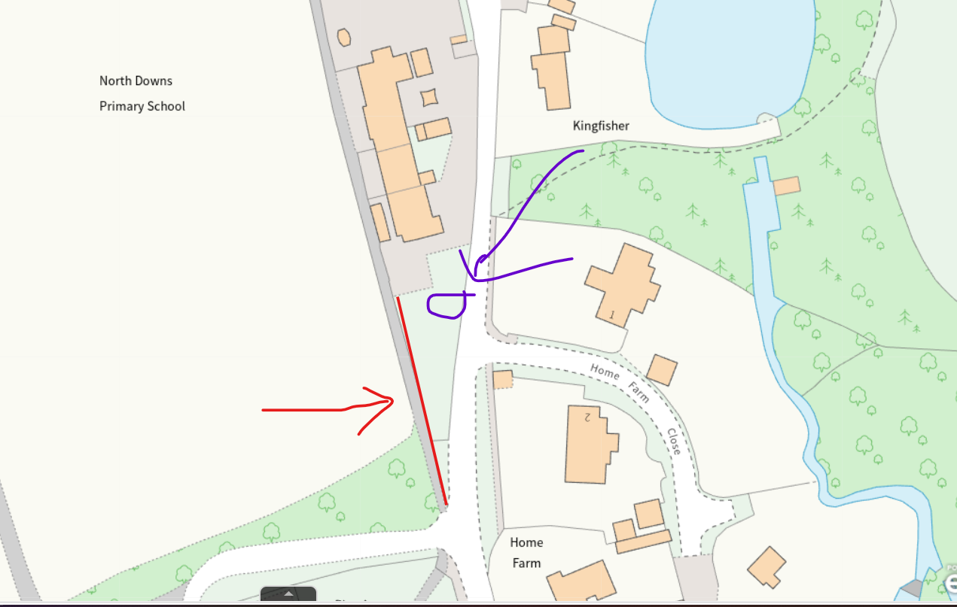
Proposed railing line shown in red; allotment water-tap/access area marked in purple.

2. Proposed Options / Quotations
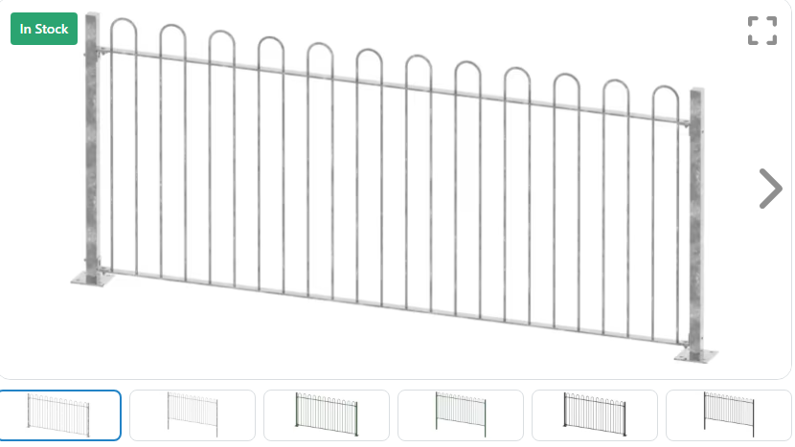
Two routes are being considered: a bespoke solution through a local forge, and a simpler standard metal-railing solution. The exact length of the run still needs to be measured on site, so the standard-railing figure below is shown as an indicative cost per metre rather than a total project price.
Option | Route / supplier | Indicative cost | Summary
1 | Betchworth Forge Ltd | REDACTED | Tony has requested a site meeting to inspect the existing arrangement and advise on the safest replacement. Meeting completed at the Betchworth School site.
2 | First Fence  1.2m High Standard Bow Top Railing Kit | Current advertised supply price: £REDACTED+ VAT per bay.  First Fence also advertises the range from £REDACTED+ VAT per metre. Installation is additional and would need a site-specific quotation | Indicative budget for standard steel railings rather than bespoke forge-made railings.  A standard galvanised-steel system with rounded tops and no pointed rail ends. It is available with dig-in or bolt-down posts and matching gates, making it a useful off-the-peg comparison for this site.  1.2m High Bow Top Fencing | Metal Garden Rails UK | First Fence Ltd  Image below

3. Site Requirements
- Railings to run along the section marked in red on the plan, continuing down towards the road.
- The replacement must provide a safe barrier for children using the school footpath and avoid sharp or projecting ends.
- Access must be retained to the allotment water tap within the area marked in purple; this may require a suitable gap, gate or other agreed access arrangement.
- The Council's preferred appearance is similar to the railings already used at Betchworth School, although a standard off-the-peg metal railing system should also be considered if it is suitable and more cost-effective.

4. What Needs to Happen Next
- Meet Betchworth Forge Ltd on site to inspect the existing railings and discuss the safest replacement arrangement.
- Measure the full length of the proposed railing run and confirm the required height.
- Confirm how access to the allotment water tap should be incorporated.
- Obtain a formal quotation from Betchworth Forge Ltd for the bespoke/supplied-and-fitted option.
- Obtain a comparable quotation for standard metal railings so the Council can compare a simpler off-the-peg option against the forge quotation.
- Agree the preferred design and cost before arranging installation.

