
BETCHWORTH PARISH COUNCIL
Proposed Public Access Defibrillator
The Hamilton Room, Church Street, Betchworth, RH3 7DN

INDEX
- Introduction
- Defibrillator Options
- Electrical Installation Quotations
- What Needs to Happen Next

Introduction
Betchworth Parish Council is considering installing a new public access defibrillator (AED) externally at The Hamilton Room. The proposed location is under the noticeboard on the car-park side of the building so that it is clearly visible and accessible to the community. The external cabinet will require a suitable electrical supply for its heater and associated functions.

Defibrillator Options
Option | Route / supplier | Indicative cost | Summary
1 | BHF Community Defibrillator Funding Programme | Potentially funded | An application has already been submitted. Since applying, we have received an email each month advising that the application has been unsuccessful. This suggests unsuccessful applications may be automatically reconsidered or resubmitted each month, so we hopefully do not need to reapply ourselves. It is unclear whether the outcome is likely to change given the number of existing defibrillators in the village, but the application appears to remain under consideration each month.
2 | Defib4Life purchase package  iPAD SP1 AED Fully Automatic Defibrillator | Defib4Life — Defib4Life Ltd £REDACTED  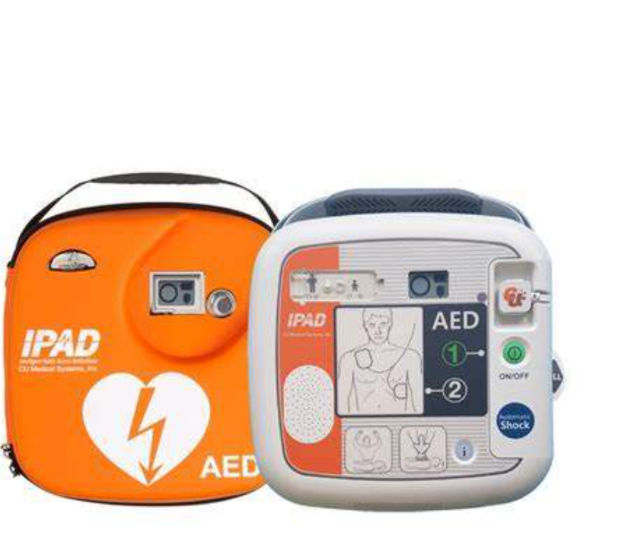  https://defib4life.co.uk/products/defibsafe-2-heated-defibrillator-bleed-kit-cabinet £REDACTED  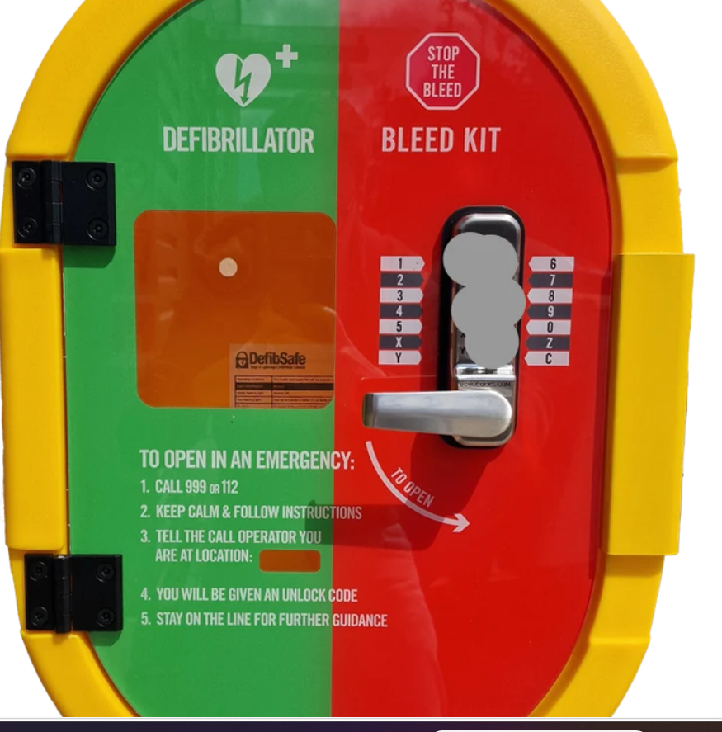  Basic Bleed Control Kit With Tourniquet Soft Pouch | Bleed Control — Defib4Life Ltd £REDACTED  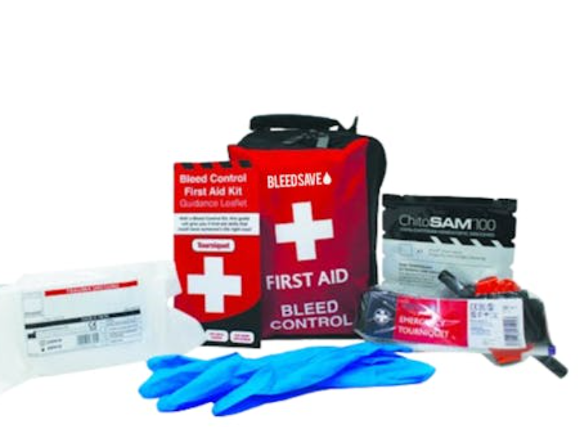 | £REDACTEDex VAT | IPAD SP1 fully automatic defibrillator with unlocked DefibSafe 2 external cabinet and bleed control kit.
3 | The Defib Store purchase package  ZOLL AED Plus Fully Automatic Defibrillator & Defib Store 4000 Defibrillator Cabinet - Buy Now  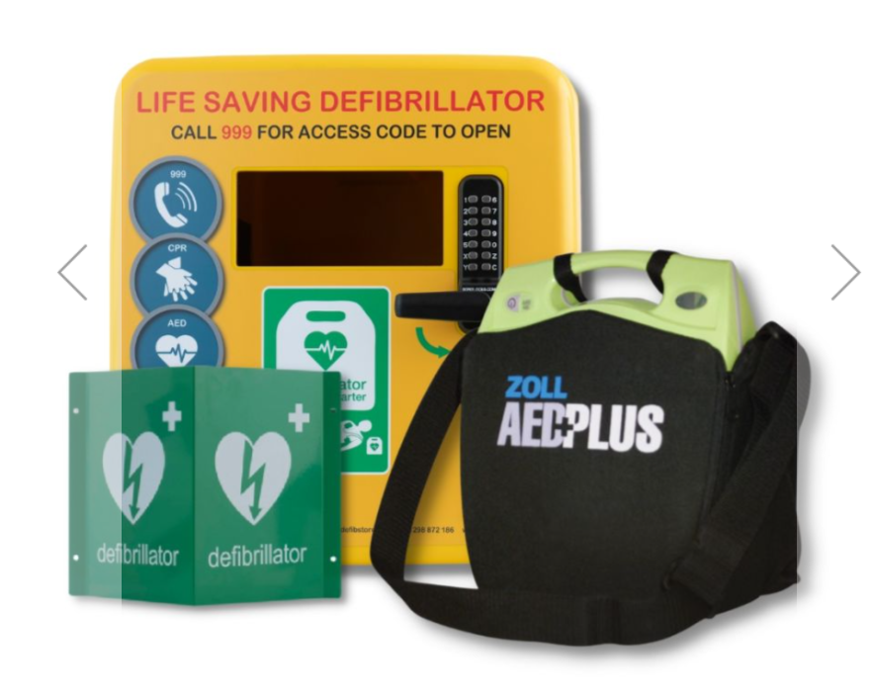 | £REDACTED ex VAT | ZOLL AED Plus fully automatic defibrillator with locked outdoor cabinet (yellow).

Electrical Installation Quotations
Two comparable quotations are required for supplying power to the proposed external cabinet, connecting the cabinet heater, providing any necessary cabling/protection, and testing and certifying the completed work.
Contractor | Quotation | Notes
Elecwork | TBC | Site visit completed. Updated quotation requested for the revised cabinet location on the opposite side of the building from the fuse board. A new/up-to-date EICR may also be required and should be priced separately if necessary.
Defib4Life Ltd | £REDACTED + VAT | Published standard external cabinet installation price where the cabinet is within 3 metres of an electrical supply.

What Needs to Happen Next
Electrical Installation Condition Report (EICR) aka Electric Certificate
- Obtain a new/up-to-date Electrical Installation Condition Report (EICR) for The Hamilton Room so the condition and capacity of the existing electrical installation can be confirmed.
- Indicative electrical costs for budgeting: a commercial EICR for a small premises is likely to be approximately £REDACTED; minor alterations or upgrades to the existing fuse board/circuits approximately £REDACTED; or, if a full replacement/new consumer unit is required, approximately £REDACTED. The actual cost will depend on the number of circuits, the condition of the existing installation, any remedial works identified by the EICR and the final specification.
- This is with The Hamilton Room management to action.

Fuse Board
- Electrician to confirm whether the existing fuse board has capacity for the cabinet supply. If not, confirm whether the unused storage-heater circuit can be repurposed, whether the existing board can be altered/upgraded, or whether a new fuse board/consumer unit is required.

