

BETCHWORTH PARISH COUNCIL

Cycling Signs on the Footpath

INDEX
- Introduction
- Sign Details
- Proposed Wording
- Current Position

1. Introduction
As requested by a Parishioner, Betchworth Parish Council is arranging two new signs for the footpath to make clear that cycling is not permitted and to direct cyclists towards the nearby bridleway.

2. Sign Details
Item | Cycling signs
Quantity | Two signs - one at each end of the path
Size | A4
Fixing | One sign to use an existing pole, 5 cm in diameter.  The other sign will require a new pole.
Brackets | Fixing brackets to be supplied
Background | White or Blue
Text | White or Black font, Clear and easily readable, with size to suit the A4 sign

3. Proposed Wording

Strictly no cycling
on this footpath.
Cyclists can use
bridleway
75m ➜

There will be one sign at each end of the path, so the arrow will need to point in the opposite direction on the second sign.

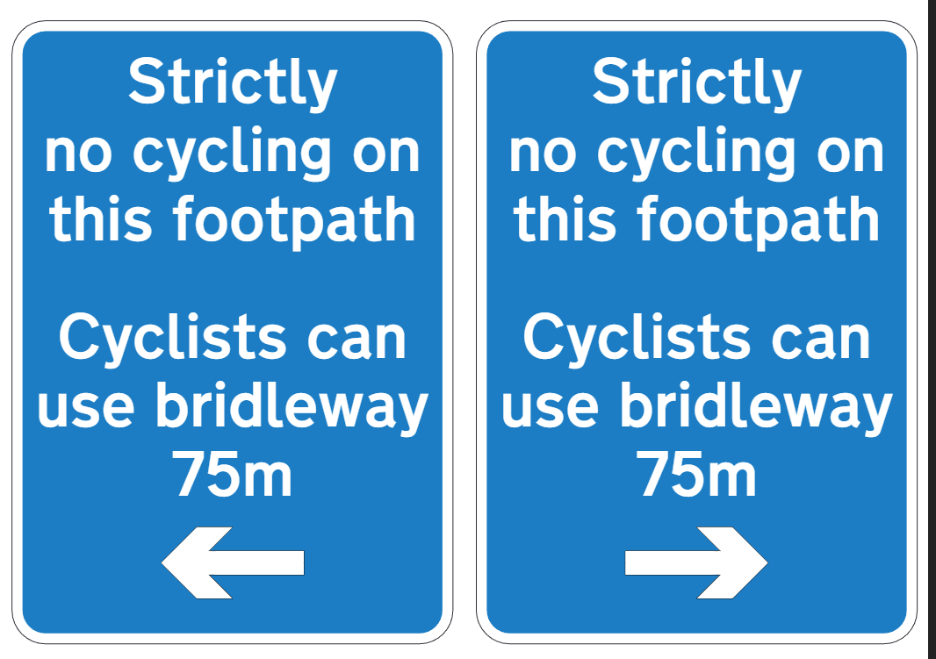

4. Current Position
Cllr Gavigan has kindly agreed to supply, fund and fit the signs, pole and brackets.

If Council were to supply, the cost would be:
KASPA Sign Products Ltd.
2 x Signs, 1x Post, Bands = £REDACTED ex VAT. Plus installation £REDACTED

SSP Direct
Ex VAT Sign £REDACTEDx 2, Post £REDACTED x 1, Banding £REDACTEDx 2 = £REDACTED plus installation REDACTED
https://www.sspdirect.co.uk/custom-signs/aluminium-custom-signs

REDACTED screenshots

