

Burial Ground Bench by Oak Tree

The current bench has been placed in memory of Mr & Mrs Kelly by their family. It is currently in a state of disrepair with some slats falling and the rest of the bench starting to be unstable.
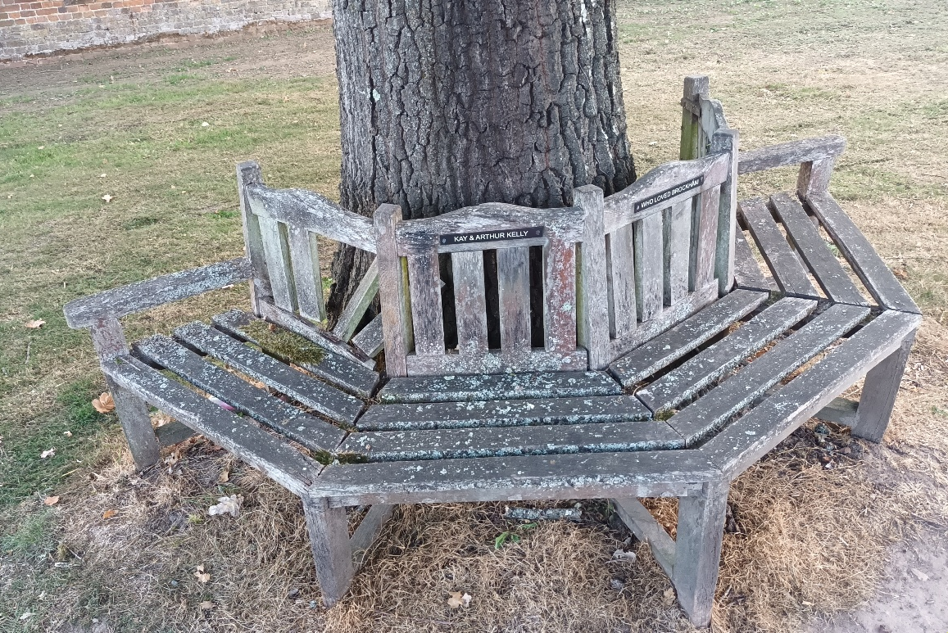

The family have requested that Betchworth Parish Council arrange for the repair, paid for by the family.
Councillors have inspected the bench and reported that although it could be repaired, its not feasible cost wise.
Option A: Ask the local Men’s Shed to help
Option B: Buy a new bench
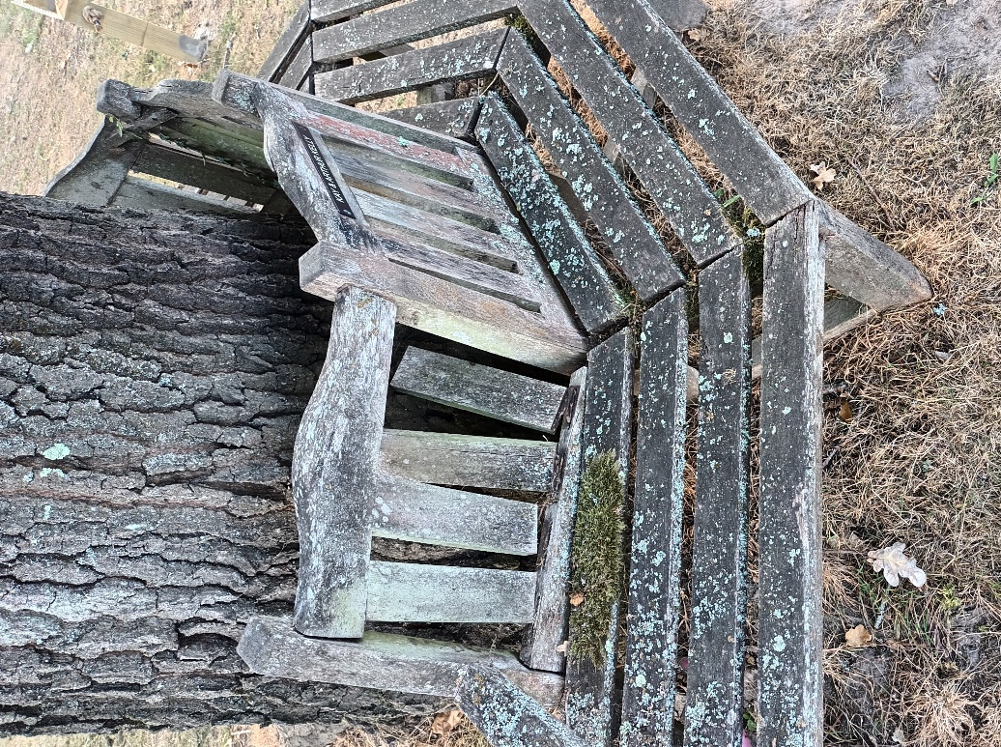

Option A: Men’s Shed
The Men’s Shed is a voluntary group who complete DIY projects.
HOME | Dorking Men's Shed

Option B: New bench
- Prices INC VAT
- Requires someone to take off the 2 plaques and reattach to the new bench (Cllr? Handyman?)
- Requires disposal of the old bench (Clerk time & mileage to take to the dump)
- The existing chain can be used to secure the new bench, assuming the key still works the lock.

Benches
https://www.gardenbenches.com/hexagonal-teak-wooden-tree-bench-large
gardenbenches.com £REDACTED plus 10% off with EXTRA10 + free delivery, 110cm internal hole. Hexagonal or Circle design. Arrives flat pack.
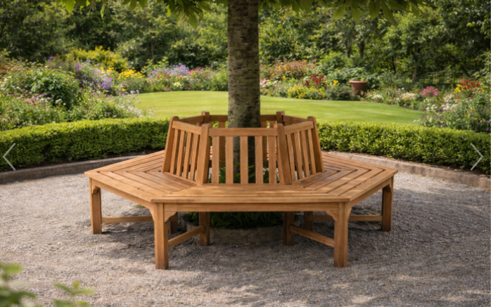
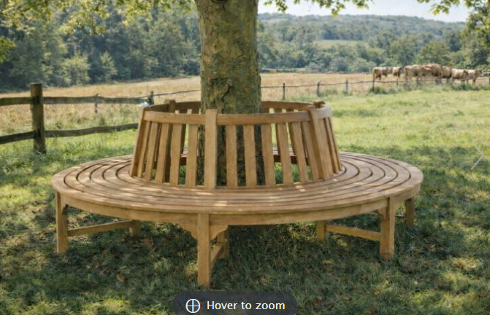

Small Half Round Teak Tree Commercial Seat
leisurebench.co.uk £ REDACTED delivery + arrives flat pack
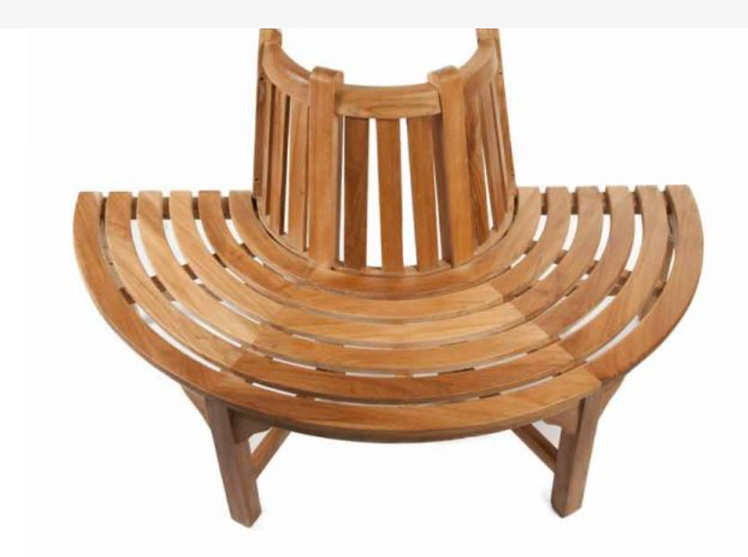

https://sustainable-furniture.co.uk/product/fowey-heavy-duty-tree-seat
£ REDACTED Swedish Redwood, arrives flat pack, inside gap 120cm, needs to be oiled. Hexagonal design.
https://sustainable-furniture.co.uk/product/reed-320cm-tree-seat
£ REDACTED Teak, arrives flat pack, inside gap 200cm, needs to be oiled. Circle design.

