

Burial Ground Memorial
The Memorial for the late Mr Wagstaff number 391 is currently unsafe.
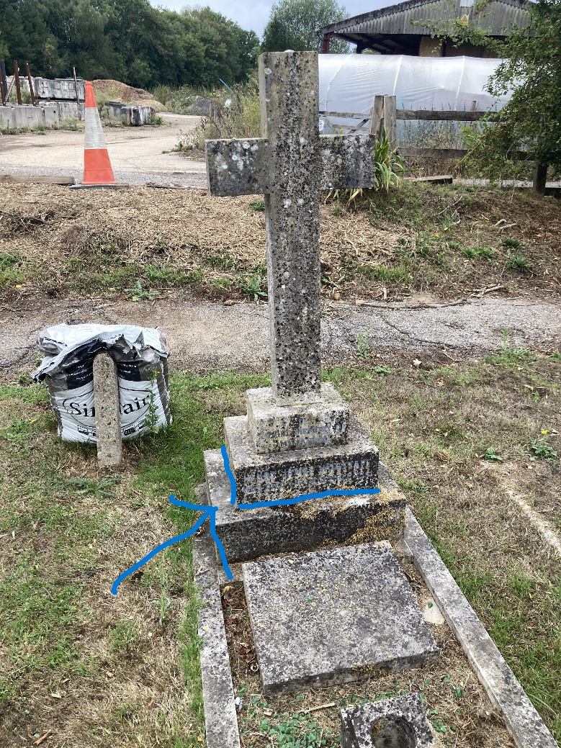
I have tried to write to the address on file and received a ‘sender not known’ letter. I have also emailed a family on Pebblehill with the Wagstaff surname.
Memorials are owned by the ERB holder and they are responsible for their upkeep.
We will need to take a step to make this one safe as it is very heavy and will cause serious hurt to a young child if it were to fall on them.
Option A – lay it down
Option B - Stonemans have quoted to mend it for £REDACTED and have reassured me that it will remain in situ and not be removed from the Burial Ground.

