Gatwick Expansion Update

Noise Research Paper
The government have released findings from their survey of local people who live close to airports - it reports that people are annoyed at the loud noise.
Aviation Night Noise Effects (ANNE) study - GOV.UK
Aviation Noise Attitudes Survey | UK Civil Aviation Authority
The research paper examines the relationship between exposure to night-time aviation noise and the subjective (self-reported) impact on sleep disturbance and annoyance.
The AEF have made recommendations based on the paper:
"Clear and irrefutable evidence of harm": AEF policy recommendations following new noise research - Aviation Environment FederationAviation Environment Federation
A news article on the matter: Many More People Bothered By Aircraft Noise Than Previously Thought AEF – 11/06/2026 https://www.aef.org.uk/2026/06/11/many-more-people-bothered-by-aircraft-noise-than-previously thought/

GACC Update
GACC are appealing the court ruling on the Gatwick expansion.

Government forecast of numbers of people to use Gatwick
The forecast on passenger numbers which looks to be an increase of 20 million people, some of whom will be passing through our village to get to Gatwick.
Proposals sent to Government to reduce flight noise and to stop expansion until noise reduced from current flights.
UK aviation forecast 2026 - GOV.UK
- In 2024 - just 13% people travelled for business purposes in 2024 (Note I am unclear how they got this data as busy Business people are unlikely to fill in survey data)
- There has been a shift to larger aircraft and a shift to international routes
- Passenger numbers are back to pre-covid levels, with a 0.21% growth predicted in the future
- If the expansion project goes ahead, Gatwick has the capacity to go from 55million people passing through the airport terminal in 2025, to 80 million in 2035.
- Below is the passenger forecast for Gatwick - these are numbers of million.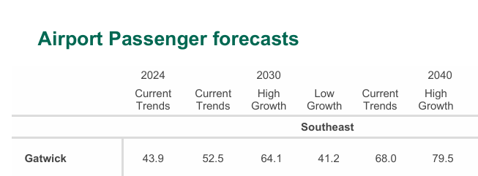

Further reading
- CAP 3013: Aircraft movements, fleet mix and noise quota usage at Gatwick, Heathrow and Stansted https://www.caa.co.uk/publication/download/28958
- Anti-airport expansion campaigners seek creation of independent aviation ombudsman Travel Weekly – 15/06/2026 https://travelweekly.co.uk/news/anti-airport-expansion-campaigners-seek-creation-of-independent aviation-ombudsman

