Data from 2021/2024 Census for Betchworth
- Betchworth (E04009565) - ONS Build a custom area profile - ONS
Summary
- An ageing population, 18% disabled, mainly affluent.
- Mainly drive to work / work from home, mainly full time L1-L9 occupations
- There are people in the village who are deprived and can’t speak English very well
- Lots of multi-bedroom housing, more than mole valley average. Flat prices have declined.
Data
- 2024 Population: 1076 people 431 households

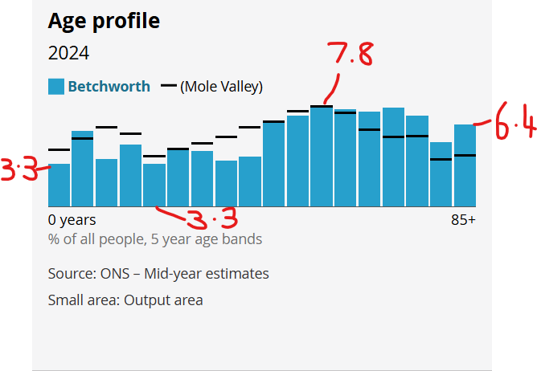
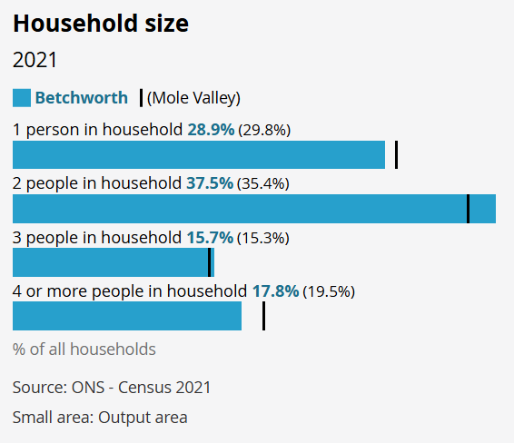
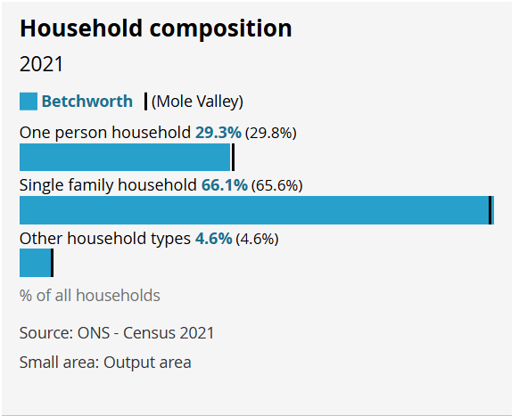
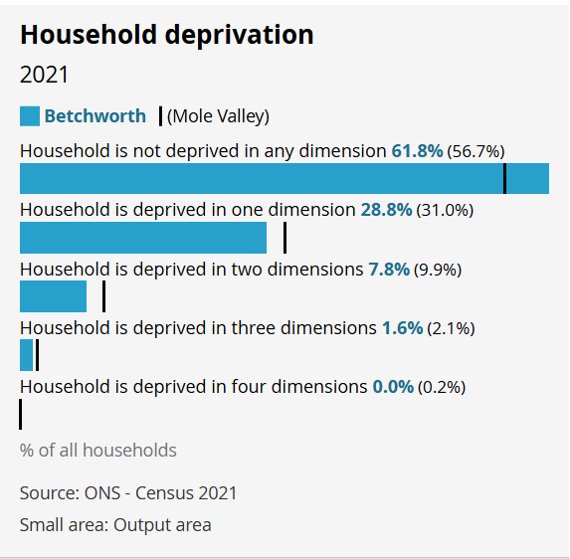
Deprivation Dimensions
Education: A household is considered deprived in education if no one has at least level 2 education (equivalent to GCSEs in England) and no one aged 16 to 18 is a full-time student. This dimension captures the lack of educational attainment and opportunities within the household
Employment: A household is classified as deprived in employment if any member, who is not a full-time student, is unemployed or economically inactive due to long-term sickness or disability. This dimension reflects the household’s access to income through work and economic participation
Health and Disability: A household is deprived in health if any member has bad or very bad general health or is identified as disabled. Disability is defined according to the Equality Act (2010) and includes individuals whose day-to-day activities are limited by long-term physical or mental health conditions
Housing: A household is considered deprived in housing if its accommodation is overcrowded, in a shared dwelling, or lacks central heating. This dimension captures inadequate living conditions that affect quality of life and well-being

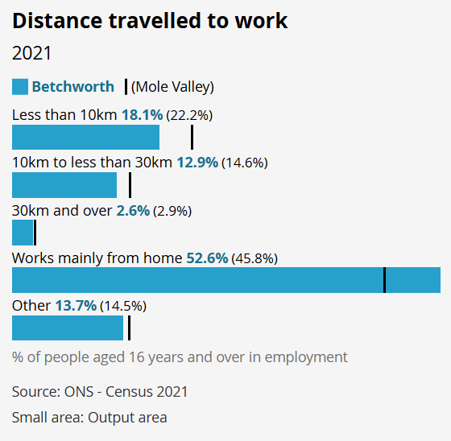
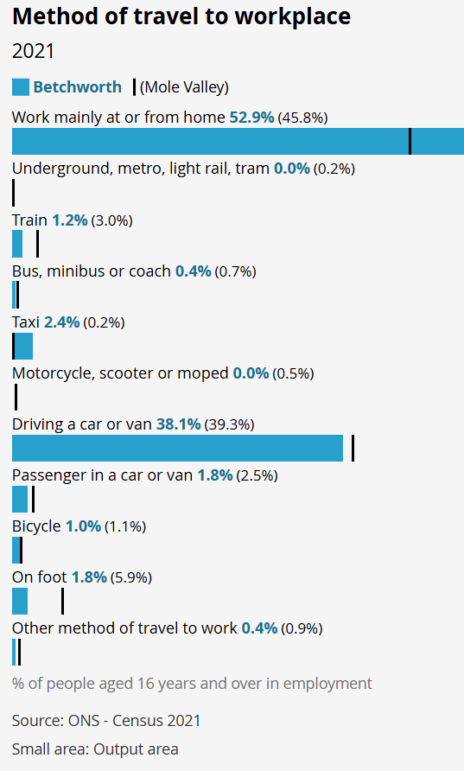
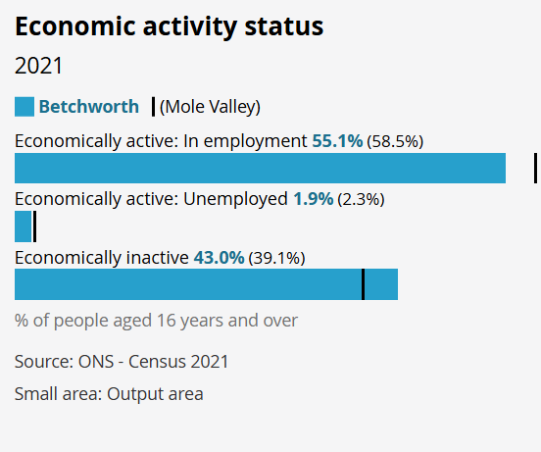
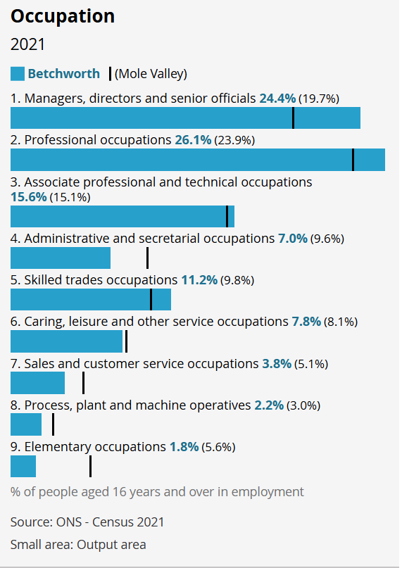
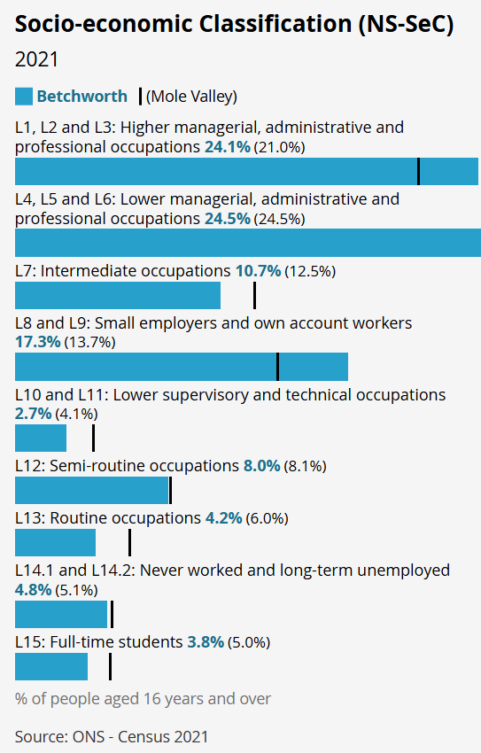
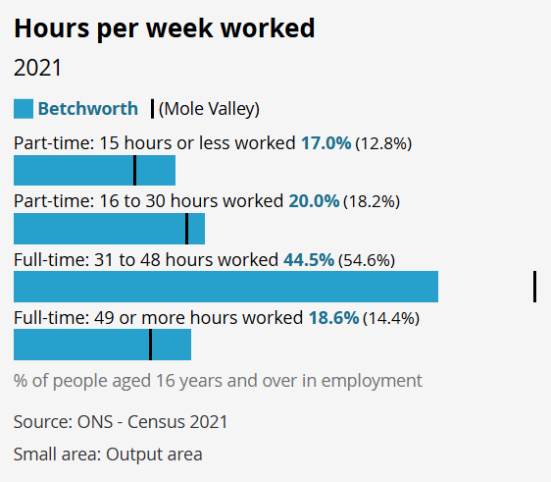
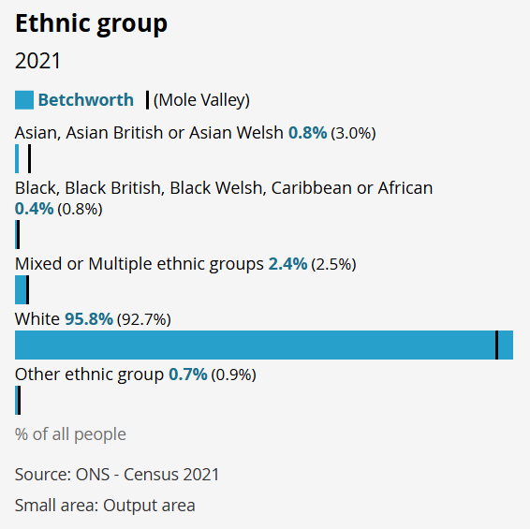
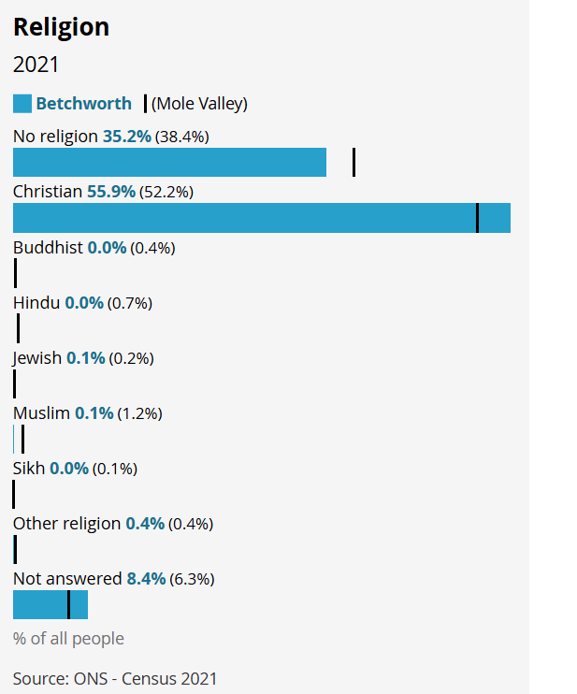
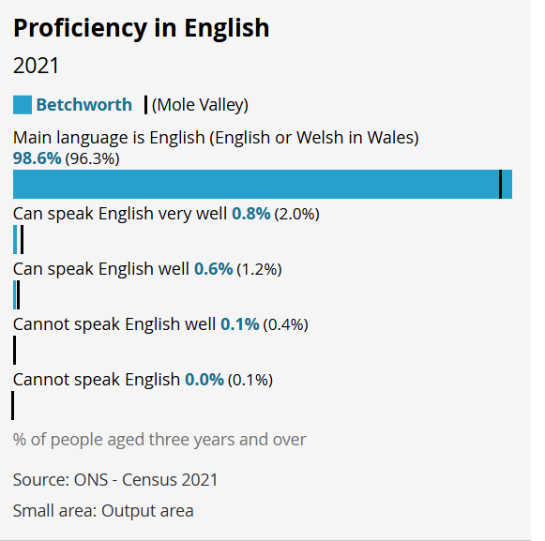
We have a couple of people who can’t speak English well in Betchworth.

