Bus Shelter Improvements
Spring bulbs have been requested for the land near to the Bus Shelter opposite the Post Office.
Amazon – £REDACTED
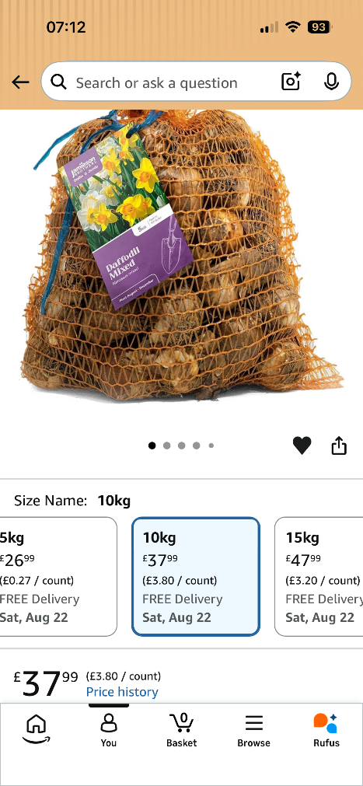
Hope Nursery - £REDACTED natural daffodils

Recommendation: REDACTED

