Tree Plaque
Following tree works at the Burial Ground, a memorial tree was removed which (unknown to the current Council) the family of the late John Bylett planted. A new tree will be planted by the family and the Parish Council wishes to provide a tree plaque in memory of the late John Bylett who was caretaker of the Burial Ground for many years.

Quotes based on wording of:
In memory of John Bylett
Who maintained this Burial Ground for 55 years

Recommendation
Recommendation of the Burial Ground working group is: A decent quality option as John gave many hours to the Parish Council. The BEL stake is standard design and seems robust and durable.

Options Summary
- REDACTED metal spike, brass metal plaque on wooden square 6x3inch. The 8x6inch is £ REDACTED. https://engravingstudios.co.uk/products/garden-memorial-with-large-ground-stake
- £ REDACTED metal spike, stainless steel metal plaque (15 x 10 cm etch engraved brushed stainless steel plaque unfilled with black enamel bonded to a 75 x 25 x 2.5cm black powder coated stainless steel stake. Tree Stake Plaques Engraving - BEL Signs
- £ REDACTED metal spike, stainless steel metal plaque on wooden square (£REDACTED for brass) 18x13cm https://plaquestore.co.uk/collections/tree-stake-plaques

Options Detail

EBay - £ REDACTED
Personalised Tree Marker plaque Silver Memorial plate with stake ANY Words | eBay UK
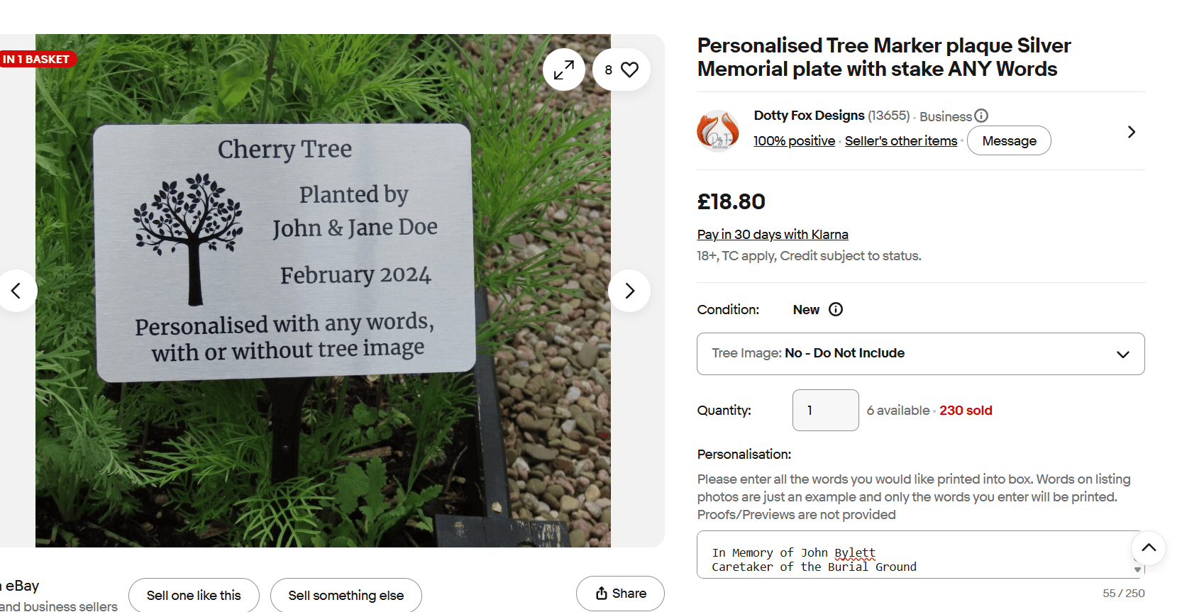

Tree Plaques | Spiked plaques | Brass Plaques
REDACTED letter

BEL: Engraved Stainless Steel Plaque 15cmx10cm £ REDACTED ex VAT Tree Stake Plaques Engraving - BEL Signs
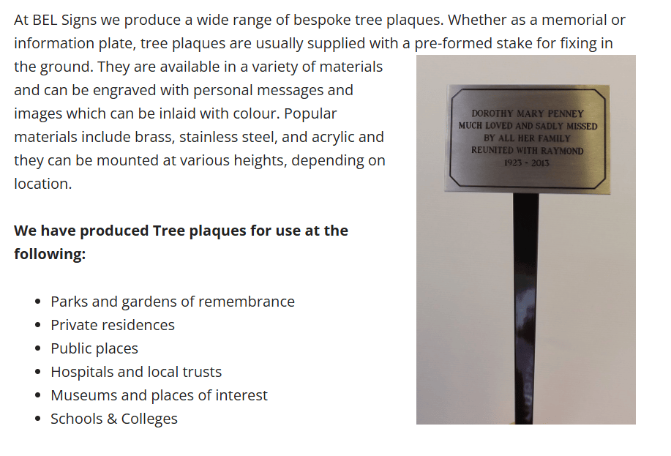
Plaquestore https://plaquestore.co.uk/collections/tree-stake-plaques
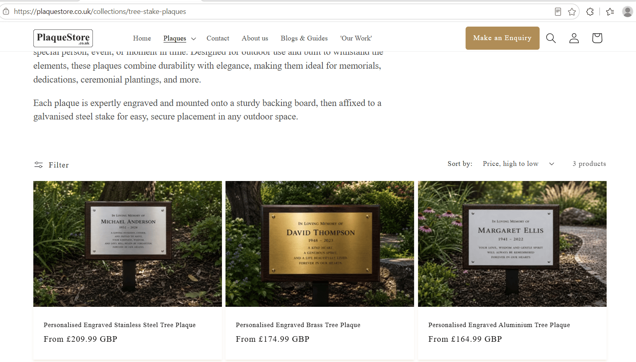

https://engravingstudios.co.uk/products/garden-memorial-with-large-ground-stake
