

BETCHWORTH PARISH COUNCIL
BURIAL GROUND

Betchworth Parish Council are updating the Betchworth Burial Ground to increase capacity in an initial phase of works. The following items are in addition to this initial phase of works to decrease the impact of these works on the Allotment residents and visitors to the Burial Ground.

Recommendation

REDACTED

Quote 4 & 5

The new entrance to the Burial Ground will now pass directly alongside the Betchworth Allotments. A new fence will protect the allotments from dogs and members of the public.

Post & rail with wire at the bottom plus 3 picket gates for the allotment paths. Replace old tap fence post which has rotted at the bottom (refer to Image 1).

Farm Fencing - REDACTEDplus VAT
Josh – £REDACTED plus VAT

Quote 6

Repair the old rope fence where the posts have come out the ground. (The green line in Image 2)

Farm Fencing - £REDACTED
Josh declined to quote for this work.
Elmscape declined to quote for this work.

Quote 7

Install new rope fence to mark the edge of the grave area (Red line in Image 2). The new Burial Ground entrance will run alongside the graves 422-428. A rope fence will indicate a line for walkers using the permissive footpath and is inkeeping with the existing rope fence in use in the older grave area.

Farm Fencing - £REDACTED
Image 1 – Betchworth Allotment (yellow) and existing Burial Ground (pink). Details the location of the quoted works.

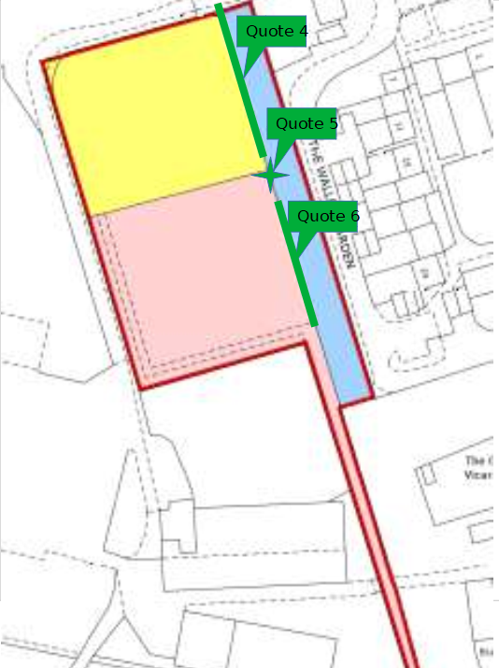

Image 2: Section of Betchworth Burial Ground showing the location of quoted works. Quote 6 - fix existing rope fence (green), Quote 2 - previously quoted rope fence (blue), Quote 7 – new rope fence (red).
