

BETCHWORTH PARISH COUNCIL

Tranquil Wood: A Rolling 2 Year Strategy

INDEX
- Introduction
- Ecological Value
- Objectives
- Management
- Delivery Plan
- What will success look and feel like?
- Appendix: Glossary

- Introduction
This is the Betchworth Parish Council strategy to deliver the objectives for Tranquil Woods as set out by the Tranquil Woods Management Team. The strategy sets out actions to deliver the objectives (section 3) over the first two years at the end of which a review will be undertaken against the achievement of objectives. This will provide an evidence-base for the next two year plan.
This strategy aims to strike a balance between ecological protection and restoration with community enjoyment, learning and health and wellbeing benefits. It integrates nature recovery and social benefit over a 2-year timeline which is enough to lay the foundations for the next strategic plan.
Figure 1A Is a Google Earth image of the woodland. The area outlined in yellow is the 10 acre woodland being acquired. The area in red is owned by two other landowners 1B shows the rough extent of ancient and modified woodland and 1C is an extract from Surrey County Council’s Local Habitat Map (part of the Local Nature Recovery Strategy.

Figure 1 A suite of Maps for Tranquil Wood.
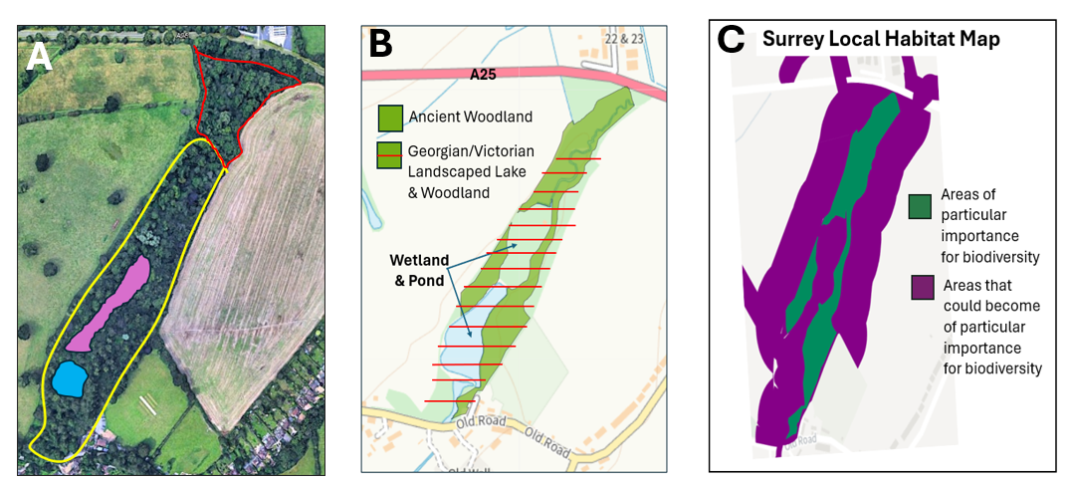

2. Ecological Value
Tranquil Wood is a special place. Its ecological value is the foundational reason for the strategy developed in this document. The 10acre woodland being acquired is the most significant part of a 4.95ha ancient & semi-natural woodland (an irreplaceable habitat) and Priority Habitat deciduous woodland. Chalk rivers Priority Habitat (as shown on magic.gov.uk) connect with Tranquil Wood to the north (Slough Brook) and south.
A preliminary ecological survey undertaken in May & July 2026 reveals that the areas of Tranquil Wood which are ancient & semi-natural woodland are classified as an Area of Particular Importance for Biodiversity (APIB), whilst the remaining and surrounding areas are classified as Areas that could become of Particular Important for Biodiversity (ACIB) in Surrey's Local Nature Recovery Strategy (LNRS). Under Surrey LNRS, Tranquil Wood APIB and ACIB falls within Potential Measures – Woodland: W1.1 Improve management of existing semi-natural woodland to support biodiversity, and a number of relevant Priority Species are included in this measure, such as rare bats, the hazel dormouse, barn owl, adder, stag beetle and rare beetles, butterflies and orchids. Areas surrounding Tranquil Wood classified as ACIB fall within Potential Measures – Woodlands, W2.1 Buffer and better connect ancient semi-natural woodland – establish new woodland or suitable edge habitats to buffer and better connect ancient semi-natural woodland.
A further point of ecological interest concerns, Georgian and Victorian landscaping and damming of Slough Brook through Tranquil Dale to create a boating / fishing lake. Over time this became silted and when the dam was breached the water drained leaving a shallow pond that filled in winter and shrank in summer and a wetland area with reed beds covering an area of about 0.6 hectares. There is potential to contribute to flood risk mediation on this tributary of the river mole and extend and enhance the biodiversity of this area. In Figure 1A the blue represents the pond which expands in winter to the size shown and shrinks in summer. The magenta area is the winter wetland which dries out in summer.
- Objectives for Tranquil Wood
The Parish Council's objectives for the acquisition of Tranquil Wood are shown below. Each objective is anchored to a specific evidential or policy basis so that progress against them can be measured and the case for acquisition supported.
3.1 Benefit – enjoyment, health and wellbeing
To provide lasting benefit and enjoyment for Betchworth parishioners through sustainable and managed access to Tranquil Wood — supporting health, wellbeing and community life — managed so as not to compromise the site's ecological value.
3.2 Community learning, education and nature recovery
To establish Tranquil Wood as a site for community learning and action — supporting outdoor education, citizen science and public engagement with nature recovery, in partnership with local schools, Forest School and the 4Bs Biodiversity Initiative.
3.3 Biodiversity
To learn about, understand, conserve and enhance Tranquil Wood's flora and fauna, with particular regard to the Priority Species identified in Surrey's Local Nature Recovery Strategy strengthening the site's role as a stepping-stone habitat connecting North Downs ancient woodland with the River Mole corridor.
3.4 Ancient woodland nature recovery
To secure long-term nature recovery of the ancient semi-natural woodland through active, evidence-led management — including deadwood retention, veteran tree protection and appropriate glade and edge management — in line with Surrey LNRS Measure W1.1.
3.5 Flood risk reduction and wetland restoration
To contribute to natural flood management in Betchworth by conserving, and where appropriate enhancing, Tranquil Wood's role within the Slough Brook – River Mole tributary system, reducing downstream flood risk to the village and enhancing the wetland and its biodiversity
  - Climate mitigation
To manage Tranquil Wood's soils, deadwood and watercourse and wetland as climate assets in their own right — protecting existing soil carbon, retaining deadwood, and using natural flood management on Slough Brook — in support of nature recovery under Surrey LNRS and in line with national woodland carbon and natural flood management guidance.

- Management
This will be a managed site to ensure a balance between wildlife and nature protection and access to the community. The site will be overseen on behalf of BPC by the Tranquil Wood Management Group which will be responsible for reviewing this strategy, management of the woodland, ongoing planning, fund raising and raising recommendations for decisions to BPC. Through its advisors, TWMG draws on expertise in woodland and wetland management and ecology. A separate paper describes the terms of reference for this group.
A volunteer group – Friends of Tranquil Wood will constitute the volunteer work force to undertake wildlife monitoring, conservation and restoration work, and provide wardens to keep a watchful eye on the woodland. In this way the management of the woodland becomes a partnership between the Parish Council and community.
- Delivery Plan — Years 1 & 2

The action plan is developed for 2 years at the end of which a review is undertaken against the objectives set and a new plan is developed for the next two years.

Each action in the plan is linked to the objective(s) it supports and paired with a way to evaluate whether it has succeeded. This will inform the Year 2 review and the plan for Years 3–4.

Year 1 — Assessment and Building Capacity for Managing the Woodland
Theme | Action | Linked objective(s) | How we will evaluate success
Access & security | Single point of entry created from Red Lion car park, gated with appropriate signs | 3.1, 3.3 | Entry point constructed and gated; no unauthorised access points observed
 | Buckland boundary fence repaired (flattened sections raised, gaps closed) | 3.3, 3.4 | Fence inspected as complete; reduction in incursions recorded via camera traps
 | Dead hedge created along the northern boundary with neighbouring land | 3.3, 3.4, 3.6 | Dead hedge constructed; use by wildlife recorded via camera trap/survey
Ecological survey & wildlife monitoring | Phase 1 Ecological Survey completed and data used to inform decisions and public information. | 3.3, 3.4, 3.6 | Survey report delivered; baseline established for future comparison. Articles written to explain findings.
 | Wildlife monitoring by camera trap, run by volunteers | 3.2, 3.3 | Monitoring programme operational; species records logged
 | Public access plan informed by survey findings | 3.1, 3.3 | Documented pathway/access decision, evidenced by survey data
Friends of Tranquil Wood (FoTW) volunteer group | Volunteer group recruited  (minimum of 15) | 3.1, 3.2 | Target volunteer numbers reached; roles filled
 | Tools, wildlife monitoring and safety equipment purchased | 3.2 | Equipment purchased within budget
 | Briefing in woodland protocols and training for clearance work | 3.2, 3.4, 3.6 | Training delivered; volunteers assessed as competent, including minimal-disturbance technique
 | Clearance of invasive species — bamboo the initial target (Figure 2) | 3.3, 3.4, 3.6 | Measured reduction in bamboo extent against Figure 2 baseline;
 | Urgent tree work undertaken – only where direct risks to people working in the woodland | 3.3, 3.4 | Trees posing a risk to woodland workers are felled or pruned.
 | Creation of new habitats — e.g. log piles, bird and bat boxes | 3.3, 3.4 | Features installed; occupancy/use recorded
 | Planting of native hedges and dead hedges along boundaries | 3.3, 3.4, 3.6 | Planting completed; survival rate recorded at end of first season
 | Initial work to manage the flow of water in Slough Brook | 3.5, 3.6 | Interventions in place; baseline flow data recorded
 | Training for wildlife monitoring and survey participation, e.g. Jan–March amphibian survey | 3.2, 3.3 | Volunteers trained; survey completed and data submitted
Planning a pathway and public areas | Options paper prepared for a public routeway, including the boardwalk option | 3.1, 3.3 | Options paper produced and considered by TWMG/BPC. Decisions made by BPC
 | Forest School site and covered meeting area planned | 3.1, 3.2 | Site identified; plan agreed.  Money raised for materials to create the site.
 | Discussions will be undertaken with the two owners of the northern two acres of the woodland re the route of any pathway through the wood. | 3.1, 3.3 | Possible extensions of the path will have been discussed and resolved.
Communications | New website created by volunteers | 3.1, 3.2 | Website system agreed, content created and launched; engagement tracked
 | Quarterly Newsletter produced by TWMG | 3.2 | Four issues per year produced and distributed
 | Articles in Parish Magazine and 4Bs Nature Magazine | 3.2 | Articles published; feedback gathered

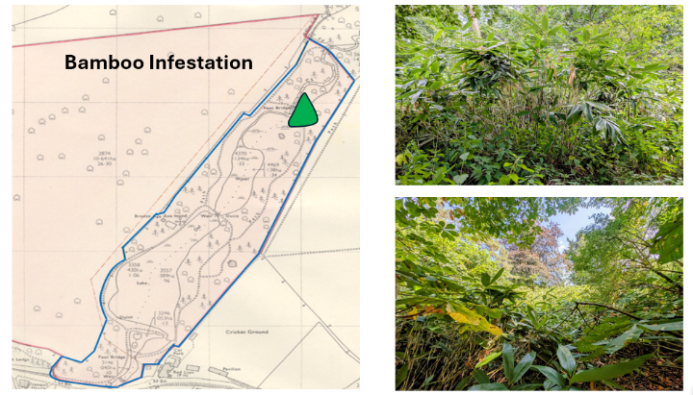
Figure 2 Bamboo infestation — the first target species for removal is bamboo, shown as the green area. This is extremely pernicious and hard to eradicate because of its rhizomatic nature.

Year 2 — Developing Infrastructure & Delivering Community Benefits
While the primary objective of Year 1 was to set up and enact management practices, setup a volunteer workforce and assess the woodland; Year 2 is focused on building the infrastructures to enable the community to benefit from the natural asset.
The strategic infrastructure aim is to build a boardwalk which would serve a number of purposes. 1) it confines visitors and pets to a single route; 2) if properly designed and positioned, it causes minimum impact on protected species of ground flora and wildlife; 3) with a suitable design, it provides the best access for users of wheelchairs, pushchairs or other mobility aids.

Theme | Action | Linked objective(s) | How we will evaluate success
Developing infrastructure for residents | Pathway(s) designed and constructed, incl. boardwalk decision. Once constructed the path can be integrated into the Betchworth and Buckland Nature Trail | 3.1, 3.3, 3.4 | Path completed; ecological impact assessed as minimal; accessibility standard met. Visitors keep to the pathway. Path integrated into the B&B Nature Trail.
 | Recommendation paper for development of the Boardwalk and grant application submitted | 3.1 | Paper considered by Council and grant application submitted.
 | Wildlife information boards installed along the trail | 3.2 | Boards installed; visitor feedback gathered
 | Forest School area cleared and prepared; first events held by reBetchworth forest school and other providers | 3.1, 3.2 | Area operational; number of sessions delivered
 | Nature-based outdoor events run for local residents | 3.1, 3.2 | Events held; attendance recorded
 | Woodland visited by local schoolchildren under teacher supervision | 3.1, 3.2 | At least one visit by school age children as part of their outdoor curriculum
 | Tree work where a threat is identified, following ecologist/arborist assessment | 3.4 | Any work follows formal assessment; veteran trees retained wherever possible
 | Additional accessible parking space(s) created | 3.1 | Spaces created and in use
Developing green infrastructure | Design for water management — Slough Brook, dam, pond and wetland area | 3.5, 3.6 | Design completed with ecologist/engineer input
 | Funding sought for engineering works | 3.5, 3.6 | Funding secured or application submitted
 | FoTW involvement in green infrastructure work | 3.2 | Volunteer hours logged
Friends of Tranquil Wood | Woodland restoration — continued removal of invasive species | 3.3, 3.4, 3.6 | Continued measured reduction in invasive cover
 | Planting of boundary hedges | 3.3, 3.4 | Survival rate recorded
 | Planting of native wildflower bulbs | 3.3 | Establishment/flowering recorded the following season
 | Participation in wildlife surveys and monitoring activities | 3.2, 3.3 | Number of surveys completed; data contributed to biodiversity baseline
Fundraising | Campaigns and/or grant applications for specific projects, e.g. Slough Brook engineering | 3.5, 3.6 | Funds raised against target; applications submitted/secured
Ecological surveys | Phase 1 Ecological Survey is extended. Money raised to pay for the extension and were appropriate volunteers are involved in survey work. | 3.3, 3.4, 3.6 | Survey undertaken (funding permitting), data gathered help build knowledge base. Volunteers involved where appropriate.
Review & forward planning | End of Year 2 review of progress against objectives using the measures elaborated in this table and feedback from volunteers and users of the woodland. | All objectives | Report produced, incorporating impact evidence and user feedback. Evidence-based forward plan prepared for Years 3–4

- What will success look and feel like?
Two years after acquisition, Tranquil Wood should feel like a place under active, visible care. A repaired boundary and a single, gated entrance will mark that change: this is somewhere someone is looking after. A small but established group of Friends of Tranquil Wood volunteers — wardens, surveyors, wetland watchers — will know the wood through all four seasons, having built its first full ecological record. Their newsletters to the community will be a tangible expression that people not only say they care about the woodland but care enough to put their own time and effort into looking after it.
Their bamboo clearance will already show visible results, and the first native hedges planted along its boundaries will have taken hold. A quiet, carefully designed pathway will let Betchworth and Buckland residents walk into the wood for the first time without threatening the ground flora or the wildlife it shelters — and, if the boardwalk ambition is realised, it may also be the first time some residents, using wheelchairs or pushchairs, have been able to get into any woodland at all. Local schoolchildren will have had their first taste of the wood as an outdoor classroom and the Forest School will have established a new base for its activities.
Because of the quarterly newsletter delivered by the Parish Council email account, together with a special issue of the 4Bs Nature Magazine dedicated to the wood, and a number of nature videos on YouTube and posted in the 4Bs Nature WhatsApp Group most parishioners have heard what's happening there, even before they've walked its paths themselves, and any nature lovers in the 4Bs will certainly be aware of the wildlife it shelters.
Work on Slough Brook's water management will be underway — the first steps toward the wood doing double duty as a flood buffer for the village while creating a more substantial and long-lasting wetland.
Set into the broader landscape, the woodland path will be connected to the Betchworth and Buckland Nature Trail adding another 500m to the experience.
All of this is a work begun: two years is only enough to make a start, to lay the foundations and build essential infrastructure to do the work of creating a valuable asset for the community and for wildlife. But it should be enough to show that Tranquil Wood has moved from an acquisition on paper to a living, monitored, cared-for place — with a track record solid enough to justify the case for what comes next.
Furthermore, by sharing the work we are doing more widely we can enhance the reputation of the 4Bs as a place that cares for nature and this can only benefit our ability to attract grants to support development of the woodland strategically in the long term.

- Appendix: Glossary

Acronym | Definition
4Bs | The villages of Betchworth, Buckland, Brockham and Boxhill
ACIB | Areas that Could become of particular Importance for Biodiversity
APIB | Area of Particular Importance for Biodiversity
B&B Nature Trail | Betchworth and Buckland Nature Trail
BPC | Betchworth Parish Council
FoTW | Friends of Tranquil Wood (volunteer group)
LNRS | Surrey's Local Nature Recovery Strategy
reB | reBetchworth nature organisation
TWMG | Tranquil Wood Management Group

