

BETCHWORTH PARISH COUNCIL
Flooding Warning System

- Introduction
The Betchworth bridge floods in winter every year and disrupts the traffic in the village. Some cars underestimate the depth and get stuck.
Betchworth Parish Council have decided to install a mechanism whereby Parishioners can check the status of the river from home.
The Environment Agency issue free flood warnings based on data from Kinsley Manor (upstream from Betchworth). BERT team informed Cllr Winter how these warnings are historically ignored for minor floods due to the data being an estimate based on readings in a different village. Given the level of chalk and underwater caves in the ground, the flood water can flow unpredictably. Information from a Betchworth river status checker can feed into the Environment Agency warning system improving accuracy of warnings locally.

- Recommendation
Cllr Gavigan recommendation of option B: Bollard due to cost and ease of installation, maintenance and annual cost.
A grant is available from Surrey Council which I shall apply for to cover the setup costs of the bollard solution.

- Option A: Camera
Cllr Gavigan met with REDACTED family who own Betchworth house, Trevor and Mick from BERT (Brockham flood team) to establish the possibility of installing a camera at the Betchworth House property to monitor flood levels of the River Mole at the start of the bridge on Snowerhill Road at the point marked “A” on the map below.
The ideal position at Betchworth House is a small area of overgrown flat land situated between the listed perimeter wall and a storage shed where the flood area would be visible by camera day and night marked “B” on the map below. Trevor and Mick recommended a 4 metre galvanised free standing pole (see picture below) would be the appropriate choice, as it would be sufficient to have the camera attached to it and would also not have to be attached to either the listed perimeter wall or the listed shed building. This would eliminate the need to request MVDC listed building consent as Betchworth house is a grade 1 listed building.
There is already power in the storage shed for a camera to be plugged in, and a wifi booster box could also be installed to pick up the wifi from the office at Betchworth House. The wifi signal was tested using Speedtest and the upload was approx. 34Mpbs which Trevor confirmed should be sufficient strength.
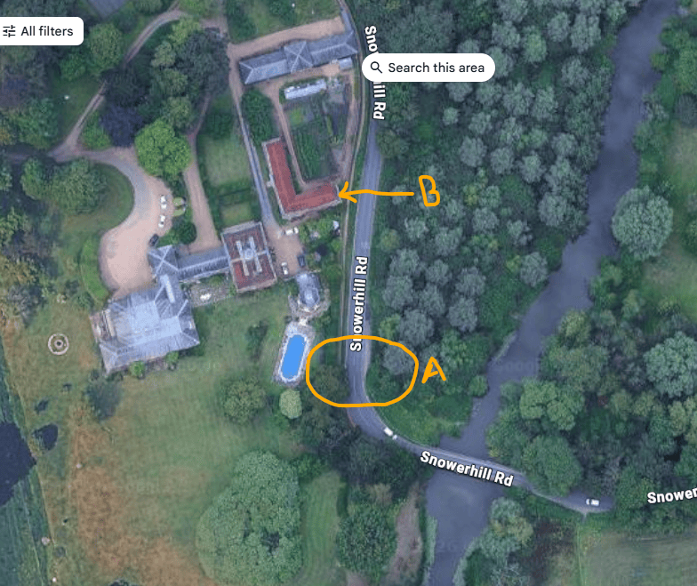
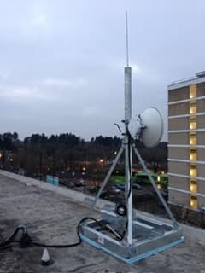

For the Betchworth camera to interact with Flood mapper and stream live pictures (something which the Brockham camera doesn’t do) there are some things that need to be considered and investigated further.
- To stream live pictures of the bridge on the Parish Council website we would need to get authorisation and register with the ICO (Information commissioners Office) and pay a data protection fee.
- We would also need to make sure we are GDPR compliant as set out below.
  - Select a Data Controller: Appoint Betchworth Parish Council to be legally responsible for the data.
  - Conduct a DPIA: Complete a Data Protection Impact Assessment to document why the camera is needed, what it captures, and how you will mitigate privacy risks.
  - Position the Camera Carefully: Angle the camera to focus strictly on the river gauge or water level, avoiding nearby windows, gardens, or pedestrian walkways.
  - Use Low Resolution or Blurring: Set the video feed to a resolution low enough that number plates and faces cannot be read, or use software to permanently blur those areas.
  - Put Up Clear Signage: Install signs near the bridge stating that a community flood-monitoring camera is operating, who runs it, and how to contact them.
  - Limit Data Retention: If you are streaming the footage live to a public website, do not record or save the history unless necessary for historical flood analysis.
- The long term maintenance of the equipment.
- Support for outages such as power trips and wifi router reboot.
- Security for the existing wifi would mean a separate SSID for the camera to eliminate possible hacking into the Hamilton’s internet.

Cost Considerations
- Pole purchase and setup
- Camera purchase and setup
- Booster and cabling purchase and setup
- Data protection fee
- Clerk hours
- Signage purchase and setup
- Video software purchase and setup
- Maintenance
- Wifi secure setup
- Product reset following power outages, router reboot

- Option B: Flood alert bollard

FloodAlert is a robust, user-friendly and low-maintenance flood monitoring solution designed for real-time river and water level monitoring. The system utilises LoRaWAN technology, enabling a single gateway to communicate with multiple sensor units, subject to site conditions and signal coverage. This product does everything this project requires.
- 24/7 local monitoring.
- sends notifications via email and SMS to designated users.
- Data is wirelessly captured, stored and displayed on a cloud-based Andel FloodAlert Portal, accessible from any internet enabled device providing real time and historic water level data.
- link to the product here https://www.andel.com/products/andel-flood-alert-bollard?parent=1799
- Through the online dashboard, users can access live and historical data, download reports
- Users can receive instant alerts via SMS, WhatsApp and email. Alert notifications can be configured across three separate warning levels to suit local requirements.

- The expected battery life is typically 1 year from activation
- Place wherever you wish - in ground or on the ground.
- Bollard sensor links to a radar stick. The radar stick then routes the readings to the nearest wifi signal. The radar stick needs mains power or can be solar powered (for extra charge)
- The readings are every 15 minutes as standard and sends height of water measurements to their web portal
- 5 phone/email can be setup per account to be auto notified of water measurements
- Must notify Environment Agency when installing and must gain permission from Surrey County Council

Estimated Indicative Pricing (Ex-VAT) - Setup
- FloodAlert LoRaWAN Outdoor Gateway: £REDACTED, or FloodAlert LoRaWAN Indoor Gateway: £REDACTED
- FloodAlert Bollard Sensor Unit: £REDACTED
- Installation day rate (two engineers): £REDACTED

Estimated Indicative Pricing (Ex-VAT) - Annual ongoing costs
- Annual subscription (per sensor unit): £REDACTED
- Annual subscription (per gateway): £REDACTED
- Annual maintenance visit: £REDACTED
