

Introduction
The Betchworth community have requested that the 2 benches in the Goulborn Green are replaced as they are rotten and at the end of their life. The back wobbles and unlikely to support an adult weight.
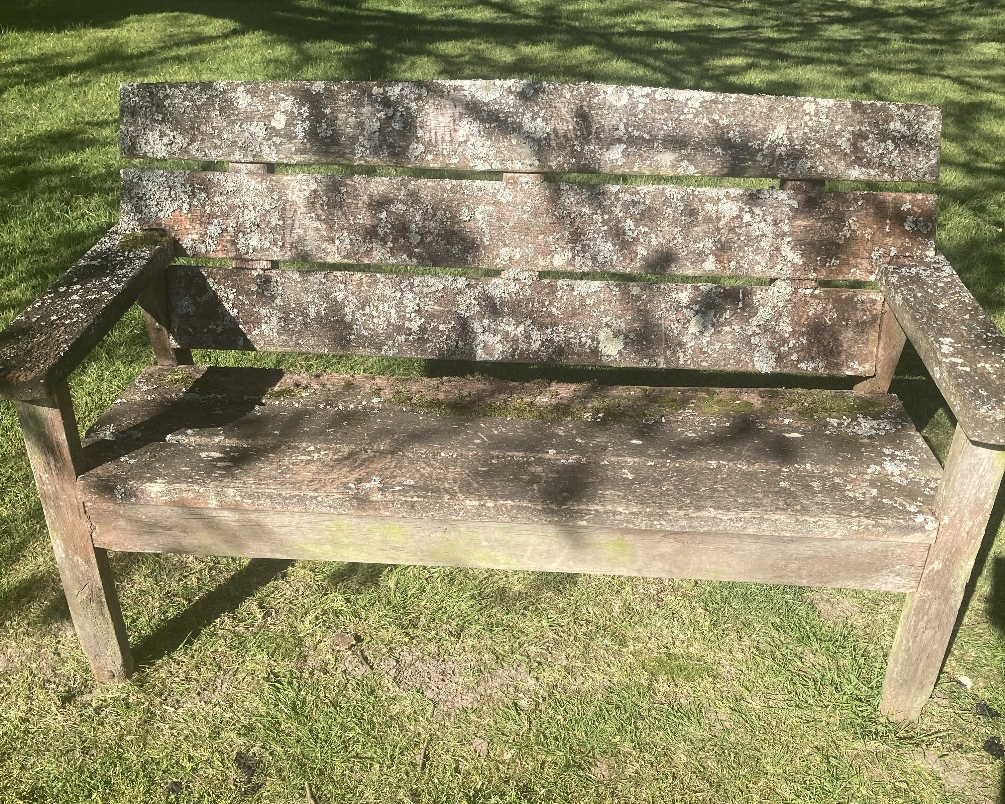
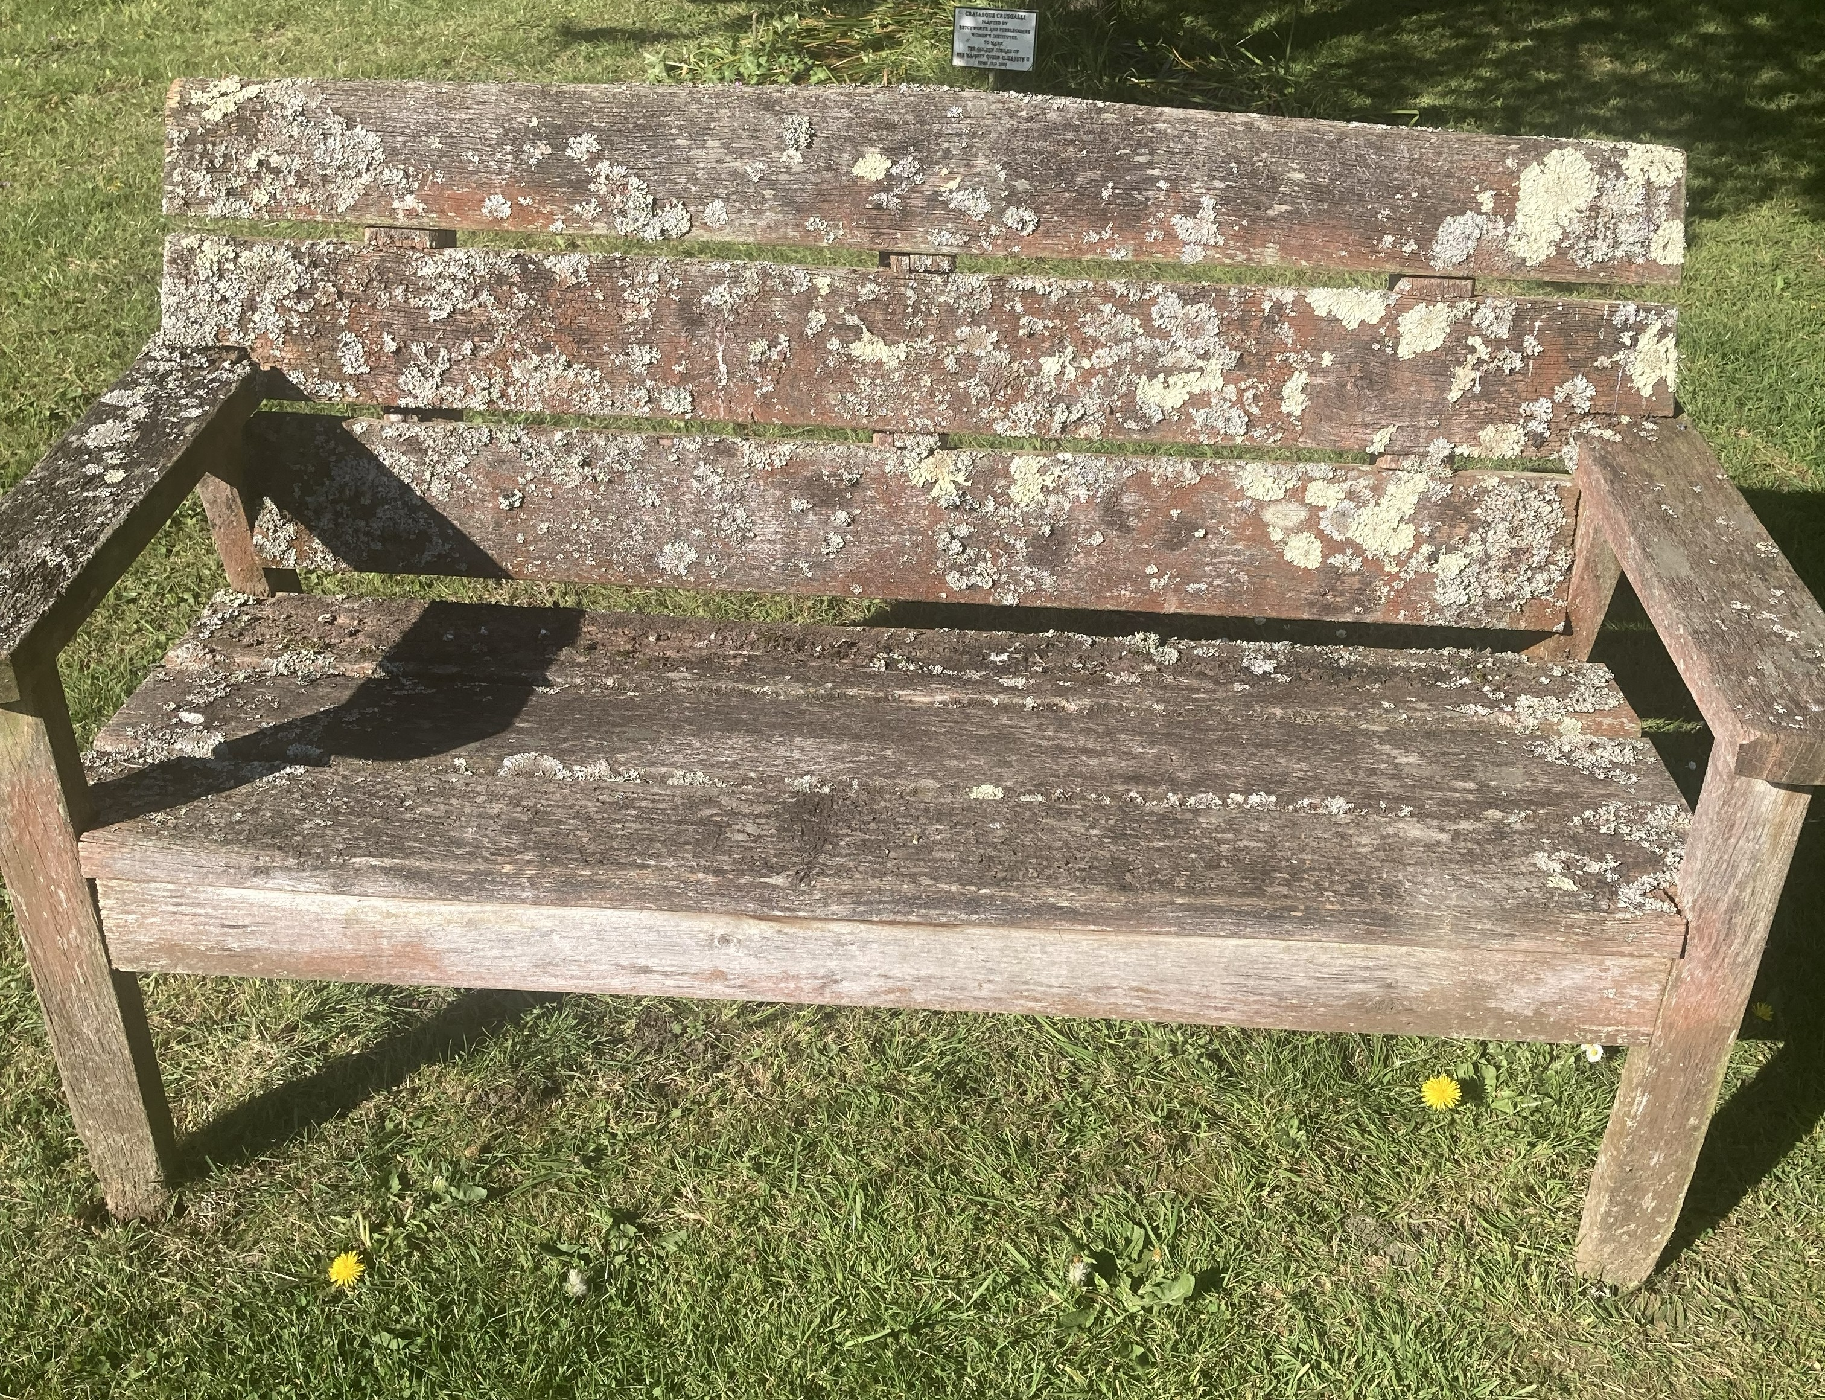

Recommendation
Working group recommendation is: Robert Dyas – Rowlinson Willington hard wood bench (Eucalyptus wood) x 2 = £REDACTED inc VAT.
Rowlinson Willington Bench | Robert Dyas £ REDACTED inc VAT

Recommendation is to use REDACTED
Based on limited research, Teak wood is more durable over other types of hard wood, however all hardwoods are more durable than softwood and would work for our benches. Councillors prefer a sustainable wood option is chosen alternative to Teak.
REDACTED anchors have been recommended as Councillors have previous experience with them.

Total Cost
£ REDACTED inc VAT (broken down as £ REDACTED for 2 benches, £ REDACTED for 2 ground anchor sets)

Wood Types
“Eucalyptus and Acacia are both durable hardwoods, but eucalyptus excels in moisture and insect resistance, while acacia offers superior hardness, scratch resistance, and rich grain patterns.” Eucalyptus Vs. Acacia For Outdoor Furniture: In-depth Differences
“The difference is that with acacia, you have to apply a finish to allow for protecting the wood from weather and also from insect attack. Teak, on the other hand, produces rich natural oils that will protect the wood even if you do not apply a finish.” “... teak cultivation and harvesting continue but in a more controlled manner.”
Teak vs Acacia Wood Difference - Pros & Cons
“Hardwoods grow slowly, taking up to 150 years to mature, making their wood denser, heavier, and more durable. This slow growth and complex cellular structure contribute to hardwood’s strength and hard-wearing qualities, making it ideal for furniture and construction that demands aesthetic appeal.” “softwoods grow rapidly, often ready for harvest within 40 years. This quick growth results in a lighter, less dense wood, which translates to softwoods being less durable than their hardwood counterparts.”
Hardwood vs Softwood: Which Wood Is Right for You?
“Redwood is the gold standard when it comes to creating outdoor wooden furniture that is designed to last. Swedish redwood is naturally resistant to moisture, making it ideal for picnic benches, outdoor dining sets and garden furniture. It also looks incredible and feels super smooth too.
Although Swedish redwood is a softwood, it remains one of the toughest materials used in the construction of benches and tables. Capable of withstanding large amounts of weight, our pub benches and picnic tables will still be standing strong after years of constant use.”
5 Reasons Why Swedish Redwood Is The Best Material

Bench Options

Robert Dyas – Redwood bench (Scandinavian Redwood) £ REDACTED
Charles Taylor Two Seat Bench Boxed | Robert Dyas

Robert Dyas – Hard wood bench (Acacia)
Garden Gear Acacia 3 Seater Rowena Bench | Robert Dyas £ REDACTED

Robert Dyas – Hard wood bench (Eucalyptus)
Rowlinson Willington Bench | Robert Dyas £ REDACTED inc VAT

Robert Dyas – Hard wood bench (Acacia)
Royalcraft Fsc 1 Turnbury 2 Seater Bench | Robert Dyas £ REDACTED (inc VAT)

Knights Garden Centre – Hard wood bench (Teak)
Daro Teak 2 Seater Bench - Knights Garden Centres £ REDACTED inc VAT

B&Q – Hard wood bench (Acacia)
Acacia Hardwood 3-Seater Garden Bench, Water Resistant Furniture for Outdoor Patio & Decking, L149.5 x W62.5 x H90cm £ REDACTED

Ground Anchors
Spirafix £ REDACTED per bench
SK311, SK313, SK314 and SK324 - General Purpose Kits | Spirafix

Ground Bolt £ REDACTED per bench
https://groundbolt.co.uk/

